Section XX
Using systems to support Homecare
Providers, commissioners and homecare companies use a range of “systems” to deliver homecare to patients. In their broadest sense “systems” can range from a paper based solution to full IT systems. It is recognised that many of the potential financial benefits from homecare (outside the VAT opportunity) will be realised by improving the efficiencies of these systems. The national Homecare Steering Group has commissioned an implementation work stream to develop a systems strategy.
The Systems: Homecare modules and functionality work stream is working (September 2012 –March 2013) to develop an output based specification for such systems to support Homecare that is then intended to be commissioned for development. It is recognised that this will be a medium to long term solution however there are a range of locally developed systems that could provide a wider number of trusts with short term benefits.
This section of the Homecare Governance Toolkit is curated by the Pharmacy Business Technology Group to support organisations to learn from others and “pinch with pride”!
(Contact judie.finesilver@cmu.nhs.uk)

Pharmacy system “General Principles”
All NHS organisations provide data to the Commercial Medicines Unit of the Department of Health on purchases of medicines. This data is imported into the PHARMEX system.
Whilst, historically, not all homecare supply has been made via hospital pharmacy systems the Hackett Report is clear that all drug usage data must be made visible to ensure appropriate management of this sector. To achieve this homecare must either be processed through hospital pharmacy computer systems – and hence data will be populated into PHARMEX – or – via FP10(HP) prescription when the drug usage data will be visible in ePACT.
To support the data analysis all organisations are asked to standardise (as much as possible) to make the usage data clear:
Supplier information:
Where any of the main 18 recognised homecare suppliers are used the pharmacy system should use the following naming conventions within their pharmacy system – this will ensure that the PHARMEX data is complete:
 | Current Supplier Name |  | Standardised Pharmex Supplier Name
1 | Air Products Plc | to be replaced with | Air Products Plc (Home)
2 | Baxter Healthcare Ltd | a new supplier to be created known as | Baxter Healthcare Ltd (Home) incorporating Willow
3 | Bupa Home Healthcare | to be replaced with | Bupa Home Healthcare Ltd (Home)
4 | Calea Ltd | to be replaced with | Calea Ltd (Home)
5 | Careology Ltd | now part of Medco Health Solutions | Careology Ltd (Home) now Medco
6 | Central Homecare Ltd | to be replaced with | Central Homecare Ltd (Home)
7 | Chemistree Homecare Ltd - incorporating Intercare | to be replaced with | Chemistree Homecare Limited (Home)
8 | DHL Healthcare | to be replaced with | DHL Healthcare (Home)
9 | Eurobay Pharma | to be replaced with | Eurobay Pharma (Home)
10 | Evolution Homecare | to be replaced with | Evolution Homecare (Home)
11 | Fresenius Kabi Ltd | a new supplier to be created known as | Fresenius Kabi Ltd (Home)
12 | Gambro Lindia AB | to be replaced with | Gambro Lindia AB (Home)
13 | Healthcare at Home | to be replaced with | Healthcare at Home (Home)
14 | Intercare Services Direct Ltd | now part of Chemistree Homecare Ltd | Intercare Services Direct Ltd (Home) now Chemistree
15 | Medco Health Solutions - incorporating Careology | to be replaced with | Medco Health Solutions (Home)
16 | Nutricia Ltd | to be replaced with | Nutricia (Home)
17 | Polar Speed Distribution Ltd | to be replaced with | Polar Speed Distribution Ltd (Home)
18 | Willow Healthcare Services Ltd | now part of Baxter Healthcare Ltd | Willow Healthcare Services Ltd (Home) now Baxter
Confirmed list from National Clinical Homecare Association XXX-YY

Where pharmacy systems are set up to order homecare drugs from a separate supplier – as listed above the phrase (Home) should be added after the supplier’s name.
N.B. If the current supplier supplies both homecare and non-homecare products please create a NEW supplier with the (Home) suffix attached
e.g. Baxter Healthcare Plc - for Non -homecare orders
Baxter Healthcare Plc (Home) – for homecare orders
Drug name:
Within some pharmacy computer systems it is more appropriate to mark the individual drug location/unit of issue files with the products included by adding the word Homecare or similar (e.g. HD) to their homecare medicine product descriptions. If this is the case individual trust’s should notify CMU how they identify these transactions. Please complete the table below with as much detail as possible and return it to PharmacyDataAnalyst@cmu.nhs.uk
Name of Trust | Example
Name of Trust | Wellness NHS Trust
Pharmacy System | JAC
Site Identification Code | RNBBD
How do you identify Homecare items within your product descriptions on your pharmacy systems? | We add the text HD to the product description
Example | Abacavir 300mg tablet HD  pack of 60
Your name and contact details | Joseph Smith jsmith@wellness.nhs.uk
Your name and contact details | 07785 573 914

Using JAC for Homecare
(Examples from The Leeds Teaching Hospitals NHS Trust - anne.larner@leedsth.nhs.uk)
LEEDS HOMECARE PROCESS SYSTEM (JAC)
- NCG /Commissioning authorisation obtained prior to commencement of therapy.
- Homecare set up with its own store
- Homecare packs to be coded separately and cross referenced to national homecare OBS list, including individual pricing arrangements (both contractual and PAS schemes)
- Homecare budgets have their own cost centres (cost centres either by specialty or consultant will need cross referencing to the Homecare system)
- Homecare suppliers to carry an identifier in the description to allow reporting on a national level
This will enable system reports to be run by Homecare service, drug, supplier and budget code.
Suggested process:
See next page

INPUT ACCESS |  | READ ONLY ACCESS
Clinical team. | Patient registration.  Prescription input including patient identifier, order no, electronic signature, delivery date required, nursing care requirements.  Amendment/updates to script. | Pharmacy,  Homecare provider (Patient registration)
Pharmacy | Pharmacy clinical validation, electronic signature.  Pharmacy order raised by system against prescription.  Tick to release to homecare provider. | Homecare provider
Homecare provider | Delivery schedule (track + trace)per patient / delivery + infusion dates.  Text alert for patient delivery.  Nursing costs if appropriate.  Reports by Patient and/ date / supplier / therapy area.  KPI reports.  Auto reminders for required prescriptions.  Information re prescription amendments. | Patients (schedule only)  Pharmacy
Patient | Online ‘’comments box’ and possible ‘APP’ to acknowledge delivery and comment e.g.  - was it on time.  - was it complete.  - attitude and appearance of driver.  - Complaints.  Ability to book delivery on line.  Reports by date, patient, supplier, therapy area, drug, KPIs. | NCG commissioner  / pharmacy provider
Pharmacy Managers  Homecare provider | Correct deliveries booked into system electronically.  Invoice certified electronically if correct.  Item(s) costed out to budget code (dispense by patient to capture non-tariff info).  Credits for rebates (Patient Access Schemes etc).  Reports available by total, drug, therapy, budget code, date/month supplier and or patient. | Pharmacy/Finance  NCG Commissioner Service Level agreements
Pharmacy | Download invoices to payments system for payment to homecare provider.  Report available by supplier and / or date.  Download to commissioner. | Pharmacy payments section Finance

Raising a manual order to cover a homecare prescription on JAC
1. Purpose

The purpose of this procedure is to define the process for raising a manual order to cover a homecare prescription

2. Scope

This procedure covers all LTH staff required to raise a JAC order to cover a homecare prescription.

3. Responsibility

It is the responsibility of the …….. to ensure that any member of staff raising a manual order to cover a homecare prescription follows this procedure.

4. Equipment

Access to JAC
Clinically authorised homecare prescription.

5. Procedure

5.1 From the JAC menu select the ORDERING AND INVOICING menu

5.2 Type in your user name and password if prompted

5.3 To raise the manual order, select ORNEW in the JAC Ordering and Invoicing
programme.

5.4 A ‘Create Released Order’ box will appear. The system requires you to enter an order
reference or message here before proceeding.

- Enter the hospital no of the patient, their initials and enough of the cost centre to identify it (ie N123456JS ADULT RHEU) select ‘ok’.

5.5 A ‘Drug Selection’ screen will appear.

- Enter part or the whole of the homecare drug description you need to raise the order for.
- A drop down list of drugs will appear.
- Select the appropriate homecare drug description and strength.

5.6 A ‘Order Item for New Released Order’ screen will appear.

- If there is more than one pack size for the drug select the required pack.
- Check that the drug location has defaulted to the homecare store.
- Enter the required number of units.
- The supplier field will default to the preferred supplier. If, for a valid reason, a different supplier is being used, clicking on the arrow at the left hand side of the field will display other optional suppliers. Ensure the correct supplier is highlighted.
- Click on order. You will be informed that the item has been added to newly released order ‘N’.
- Selecting ‘ok’ will display the order on screen.

5.7 The ‘ORNEW –Create Released Order’ screen will display the order details including value.

- A ‘Delivery Message’ field is available (top left of screen). Enter the amount and frequency required. After entering the message click on the order away from this field to prevent the message being lost. This message will then appear on the printed order and inform the procurement team that this is a confirmation order and not to be forwarded onto the company.
- Selecting ‘Order New Item’ button at the bottom of the screen allows you to add further lines to the order. If this facility is used you must ensure that the items are being raised against the correct supplier.
- You can select the ‘Cancel Order’ button at the bottom of the screen if you decide not to continue with the order for any reason.
- Selecting ‘Close’ will file the completed order.

    - The completed order will be printed at LPS.

    - Annotate the order no onto the prescription.

    - Ensure any ‘cost per case’ lines have the patient(s) hospital no included on the prescription.

    - Fax the prescription to the relevant company.

    - Notify the procurement team of any related drug cancellations to enable JAC to report accurately on any outstanding deliveries.

Raising a manual order to cover a homecare prescription for Lenalidomide
1. Purpose

The purpose of this procedure is to define the process for raising a manual order to cover a homecare prescription for Lenalidomide

2. Scope

This procedure covers all LTH staff required to raise a JAC order to cover a homecare prescription Lenalidomide

3. Responsibility

It is the responsibility of the Pharmacy Procurement Business to ensure that any member of staff raising a manual order to cover a homecare prescription for Lenalidomide follows this procedure.

4. Equipment

Access to JAC
Clinically authorised homecare prescription.
Fax Machine

5. Procedure

5.1 From the JAC menu select the ORDERING AND INVOICING menu

5.2 Type in your user name and password if prompted

5.3 To raise the manual order, select ORNEW in the JAC Ordering and Invoicing
programme.

5.4 A ‘Create Released Order’ box will appear. The system requires you to enter an order
reference or message here before proceeding.

- Enter the hospital no of the patient, their initials and enough of the cost centre to identify it (ie N123456JS MED ONC) select ‘ok’.

5.5 A ‘Drug Selection’ screen will appear.

- Enter part or the whole of the homecare drug description you need to raise the order for.
- A drop down list of drugs will appear.
- Select the appropriate homecare drug description and strength.

5.6 A ‘Order Item for New Released Order’ screen will appear.

- If there is more than one pack size for the drug select the required pack.
- Check that the drug location has defaulted to the homecare store.
- Enter the required number of units.
- The supplier field will default to the preferred supplier. If, for a valid reason, a different supplier is being used, clicking on the arrow at the left hand side of the field will display other optional suppliers. Ensure the correct supplier is highlighted.
- Click on order. You will be informed that the item has been added to newly released order ‘N’.
- Selecting ‘ok’ will display the order on screen.

5.7 The ‘ORNEW –Create Released Order’ screen will display the order details including value.

- A ‘Delivery Message’ field is available (top left of screen). Copy the patients references into here. After entering the message click on the order away from this field to prevent the message being lost. This message will then appear on the printed order and inform the procurement team that this is a confirmation order and not to be forwarded onto the company.
- Selecting ‘Order New Item’ button at the bottom of the screen allows you to add further lines to the order. Add any ancillary drugs to the order by repeating the steps in 5.6 above (a list of agreed ancillary drugs are attached)
- Add one ‘’H@H SERVICE FEE (FOR NON TARIFF DRUGS) CHARGE’’ to the order.
- You can select the ‘Cancel Order’ button at the bottom of the screen if you decide not to continue with the order for any reason.
- Selecting ‘Close’ will file the completed order.

    - The completed order will be printed at LPS.

    - Annotate the order no onto the prescription.

    - Ensure any ‘cost per case’ lines have the patient(s) hospital no included on the prescription.

    - Fax the prescription to the relevant company and to the Procurement team on ext 27047 for information.

    - Post prescription to Healthcare at Home

    - Notify the procurement team of any related drug cancellations to enable JAC to report accurately on any outstanding deliveries.

Supportive medication list for lenalidomide homecare:

Omeprazole 20mg capsules
Omeprazole 10mg capsules
Dexamethasone 2mg tablets
Allopurinol 300mg tablets
Allopurinol 100mg tablets
Tinzaparin 4500units injection
Tinzaparin 3500 units injection
Enoxaparin 40mg injection
Enoxaparin 20mg injection
Lansoprazole 30mg capsules
Lansprazole 15mg capsules
Sodium Clodronate 800mg tablets
Ranitidine 150mg tablets
Aspirin 75mg dispersible tablets
Aciclovir 200mg bd
Aciclovir 400mg bd
Prednisolone 5 mg Tablets

Using Ascribe for Homecare
(Example from Harrogate & District Foundation NHS Trust - Kevan.Bradley@hdft.nhs.uk)

Homecare using the Ascribe Pharmacy System

Product: Pharmacy (v8/v9/v10)

Contents
2 Overview 14
2.1 Introduction 14
3 Ascribe Setup 15
3.1 Separate Stock Location 15
3.2 Drug and Other Costs 15
3.3 Suppliers 15
3.4 Cost Centres 15
3.5 Episodes 15
3.6 Consultants 15
3.7 Homecare/Supplier Record 15
4 Ordering Homecare via Ascribe 17
4.1 Ordering Drugs 17
4.2 Ordering Service Fees 17
4.3 Orders and Order Numbers 17
4.4 Orders to Homecare Provider 18
5 Receipt of Drugs & Service Fees 19
5.1 Invoice and GRN 19
5.2 GRN/POD checks 19
5.3 Receipt 19
6 Invoice Reconciliation 20
6.1 Individual Invoices 20
6.2 Consolidated Invoices 20
6.3 Batches/Balancing 20
7 Dispensing 21
7.1 Drugs 21
7.2 Service Fees 21
7.3 Episodes 21
7.4 Templates 21
8 Finance 23
8.1 Type of Supplier Invoice 23
8.2 Credit Notes 23
8.3 Interfacing with Accounts Payable 23
8.4 Separation of Duties 24
8.5 G/L Interface 24
9 Reporting 26
9.1 Finance Manager 26
10 Appendix A – Setup Drugs and Other Costs (Service Fees) 27
10.1 Separate Drugs 27
10.1.1 NSV Codes 27
10.1.2 Drug Descriptions 27
10.1.3 V.A.T. 27
10.1.4 Look-Up Code 27
10.1.5 Ledger Codes 27
10.1.6 Local Codes 27
10.1.7 Contract Prices 27
10.1.8 Notes 27
10.2 Service Fees and Other Costs 27
10.3 Cost Centres for Services Fees 27

Amendment Record

Revision History

Issue Number | Author | Date | Change
1.0 | Kevan Bradley | 25/09/2012 | Version 1.0 – first draft

Overview

Introduction
This document suggests how to:
- Set up Ascribe Pharmacy System to recording Homecare transactions and dispensing.
- Process those transactions.
- Use Financial and Reporting functions.

It assumes a working knowledge of Ascribe especially Stores and Dispensing functions.
Different sites will have different functionality depending on the version and modules installed.
The document is a working document and is designed to be added and corrected by sites. Please feel free to either amend the document and return or email comments/corrections to the author at:
homecare@hdft.nhs.uk

Ascribe Setup

Separate Stock Location
A separate stock holding for Homecare is the ideal structure. This allows all homecare items to be easily ordered and dispensed. In addition, if you use Finance Manager, it is easy to review the stock-holding balance sheet and ensure stock levels equal zero. It also makes reporting much easier. Where this is not possible then using a different NSV Code range and/or structured description and/or structured local code will allow easy identification of homecare items.

Drug and Other Costs
To ensure the correct items appear on the PMR it is essential to distinguish between the actual drugs supplied and the other services provided by the Homecare companies. In addition this distinction allows for clear costing of drugs and services.
(See Appendix A for possible ways to organise the above).

Suppliers
Suppliers should be setup or amended to follow the naming convention defined by CMU – see Pharmacy Systems: General Principles authored by Judie Finesilver.

Cost Centres
Service fees should be separated from drug costs (where possible) but will need allocating to a ledger code. This can be done by setting-up a cost centre for each therapy area eg Methotrexate (Rheu) and Methotrexate (Derm) and having ward stock lists containing just the service fees and any other non-drug costs.
(See Appendix A for possible ways to organise the above).

Episodes
In Web Pharmacy (V9 onwards) the dispensing transaction should be allocated to a pre-determined episode for each type of use e.g. OP Rheumatology. This allows other dispensers to quickly find or review the homecare drugs a patient has been/is being given. Later versions allow the creation of episodes specifically for homecare use ie a homecare episode can be created making it easier for other users to recognise this patient is a homecare user.
In V8 consideration should be given to setting-up a “dummy” Homecare ward for the same reasons.

Consultants
The relevant consultants should already be setup on all systems and all dispensing should made against those consultants.

Homecare/Supplier Record
It is useful to record the details of contract drugs, cost codes on a “reference form” as per the screenshot below:

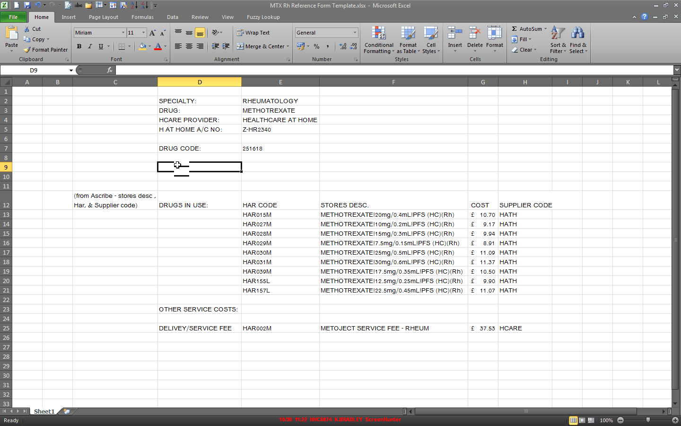

Ordering Homecare via Ascribe

Ordering Drugs
After clinical checking, each prescription received should be used as the basis for creating an order in Ascribe.

Ordering Service Fees
Service fees and other costs are setup as per 10.2 and are added to the order as separate line items. These will vary according to the relevant contract and can be subject to change during the life of the contract.

Orders and Order Numbers
Orders are created in the normal way, printed, and authorised – the patient’s number can be added at this stage so that it appears on the face of the order –see below. The relevant order number should be recorded on the prescription. If using a separate site then order numbers can have their own prefix e.g. HCD (HomeCare Drug).

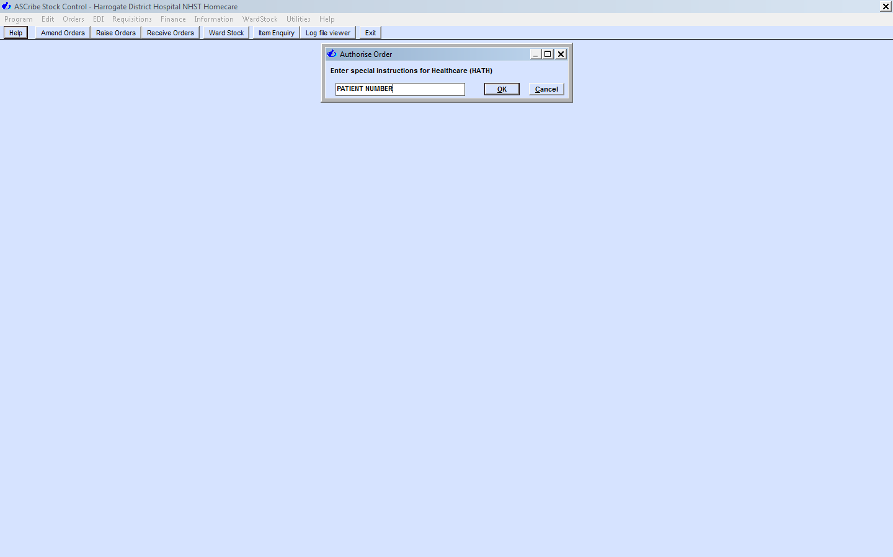

A batch/fax header sheet can be used to control the paper flow:
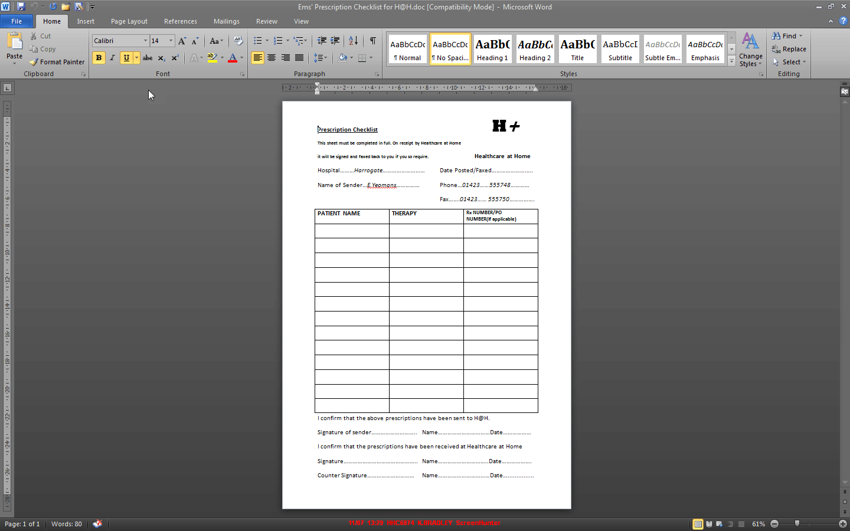

Orders to Homecare Provider
Prescriptions and the batch/fax header should be sent to the homecare provider by the method agreed with your provider. Urgent items can normally be faxed with the original to follow in the post.

Receipt of Drugs & Service Fees

Invoice and GRN
Receipt of drugs & other services is initiated when the homecare provider sends invoices and proof of delivery.

GRN/POD checks
Normal Trust goods receipt checks should take place against the prescription. Any queries need to be resolved with the supplier.

Receipt
Drugs and other services are received via the normal receiving orders option in Ascribe/Stores/Orders/Receive Goods.

Invoice Reconciliation

Individual Invoices
Following receipt of goods the invoices can be reconciled in Ascribe either before or after dispensing according to your Trust SOPs. Individual invoices are reconciled as normal.

Consolidated Invoices
Consolidated invoices are difficult to reconcile as each order can only be matched to a single invoices number. Add a suffix of A, B, C, etc to the suppliers invoice number and reconcile as single invoices.

Batches/Balancing
Using your reporting tool, a report of goods received and not invoiced can be run for homecare suppliers (identified by 3.3).Following each batch of invoices reconciled, a check should made that all invoices have reconciled:
1.On Day1 run Goods Received and not Invoiced xxx
2. Add Homecare orders received xxx
----
3. Less Homecare invoices reconciled xxx
----
4. Calculated Goods Received and not Invoiced ___
5. On Day2 run Goods Received and not Invoiced xxx

4 and 5 should be equal. This is especially useful for consolidated invoices to ensure that no individual deliveries have been missed.

Dispensing

Drugs
Drugs should be dispensed as normal against an agreed episode (V9 and above) and ward/cost centre (V8). One label can be generated for the full number of injections etc and affixed to the order.

Service Fees
Service fees can be raised as “ward issue” using the cost centres setup in 3.4. The cost centre setup (see 10.3) allows for the entry of a requisition number on issue, which should be the patient’s hospital number. Using patient’s number as requisition number allows for identification of fees with drugs when reporting.

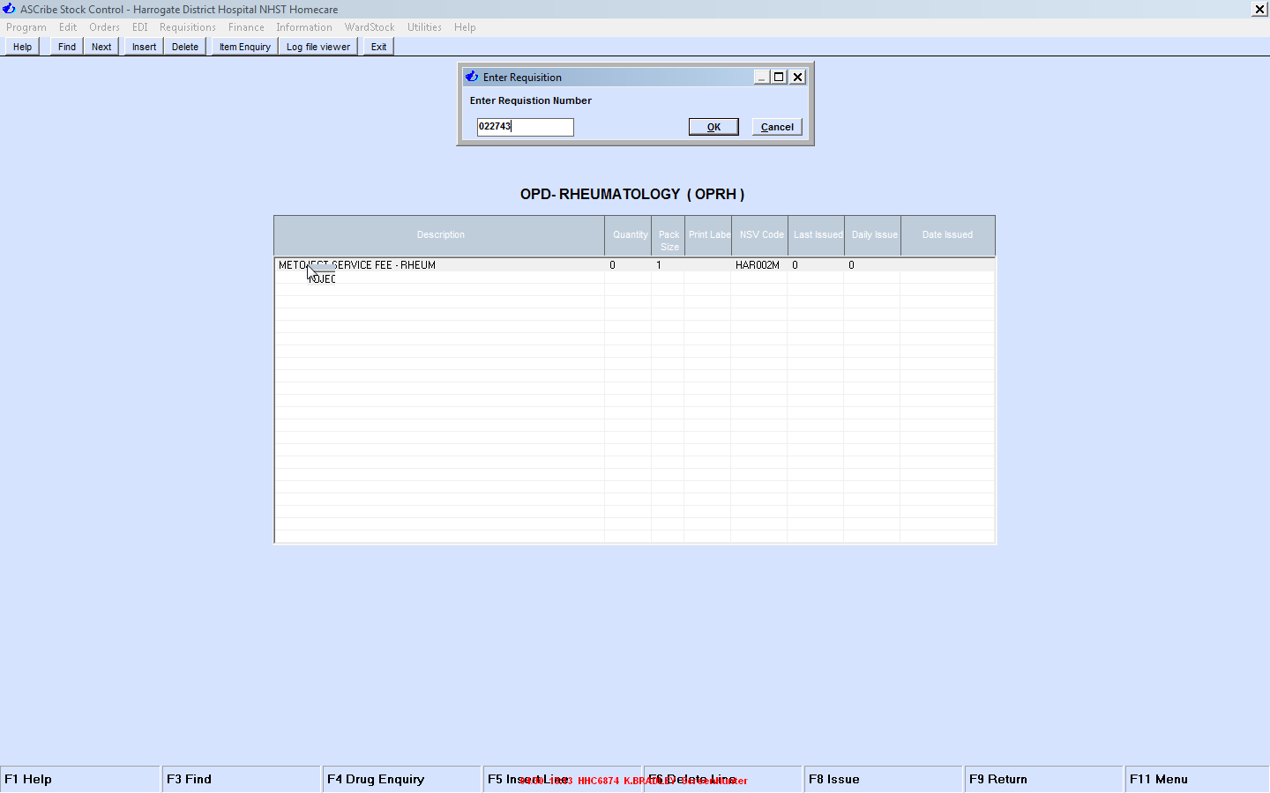

Episodes
The same episode/ward can be used for all dispensing for particular therapies. In v10.? Onwards a homecare episode can be created

Templates
In V9 and above a homecare template can be setup to give consistent directions. Adding “homecare” in the comments field allows the search facility to find the correct template each time:
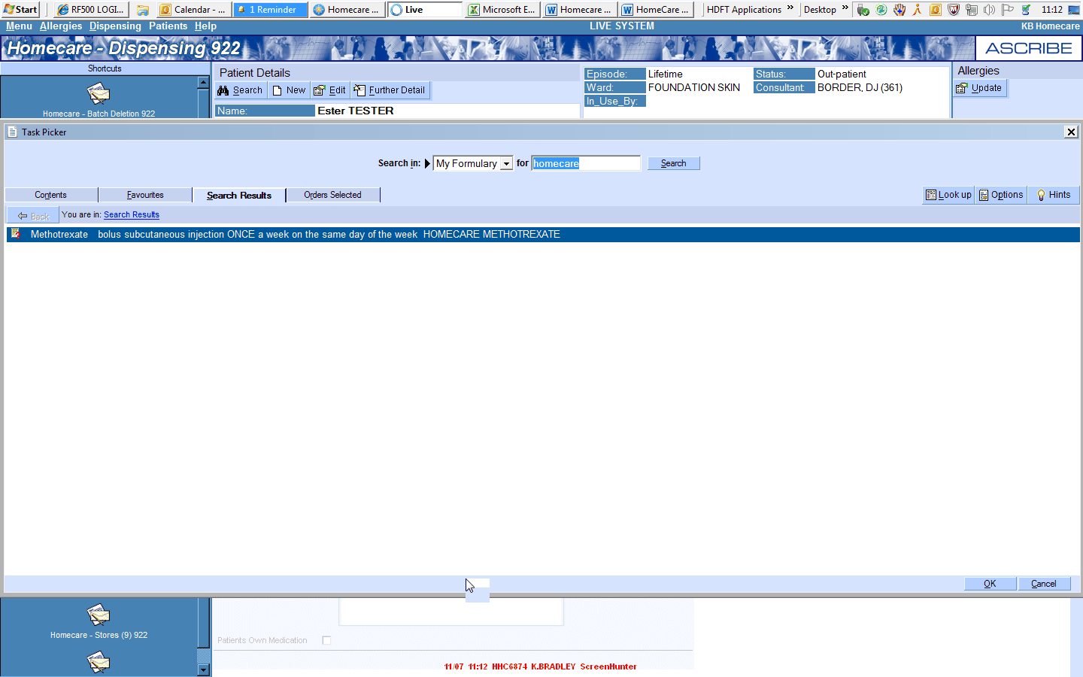

Finance

Type of Supplier Invoice
Consideration needs to be given to how the Trust is invoiced for the services – see the table below:
Invoice Type | Ascribe | Accounts Payable | Interface
Single Invoices | Matches order in Ascribe, Easy to reconcile invoice. | Can be large number of invoices. Need to consider this in terms of AP workflow or if using shared services (charge on per-invoice basis). | Can be included in electronic interface with other invoices.
Consolidated Invoices | Still need to match to individual orders. Need to use a batch record to ensure all orders on invoice are reconciled | May be cash flow implications for a smaller number of large value invoices | Cannot be interfaced as appear as individual invoices.

Credit Notes
Errors found in 5.2 & 6 may require credit notes. The receipt and/or reconciliation may need to be held pending receipt of the credit note.

Interfacing with Accounts Payable
Depending on whether you decide to interface or not, the AP Interface in Genfin application can amended. One of the mapping tables allowing the exclusion of suppliers:
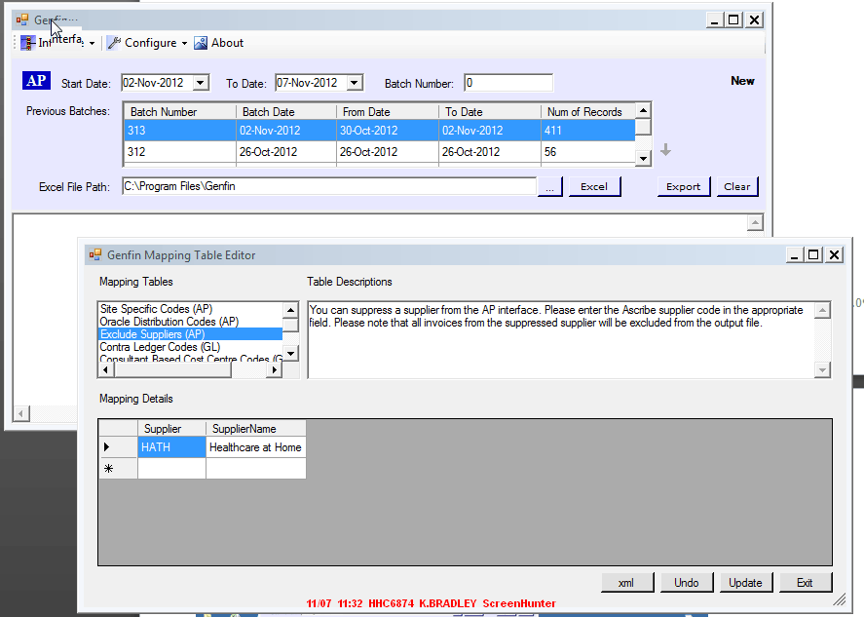

Separation of Duties
Per good financial controls ordering, receipt of goods, invoicing and dispensing should all be performed by different individuals or sections of the department.

G/L Interface
Both the drugs and other costs will appear in the GL Interface file with the correct coding:
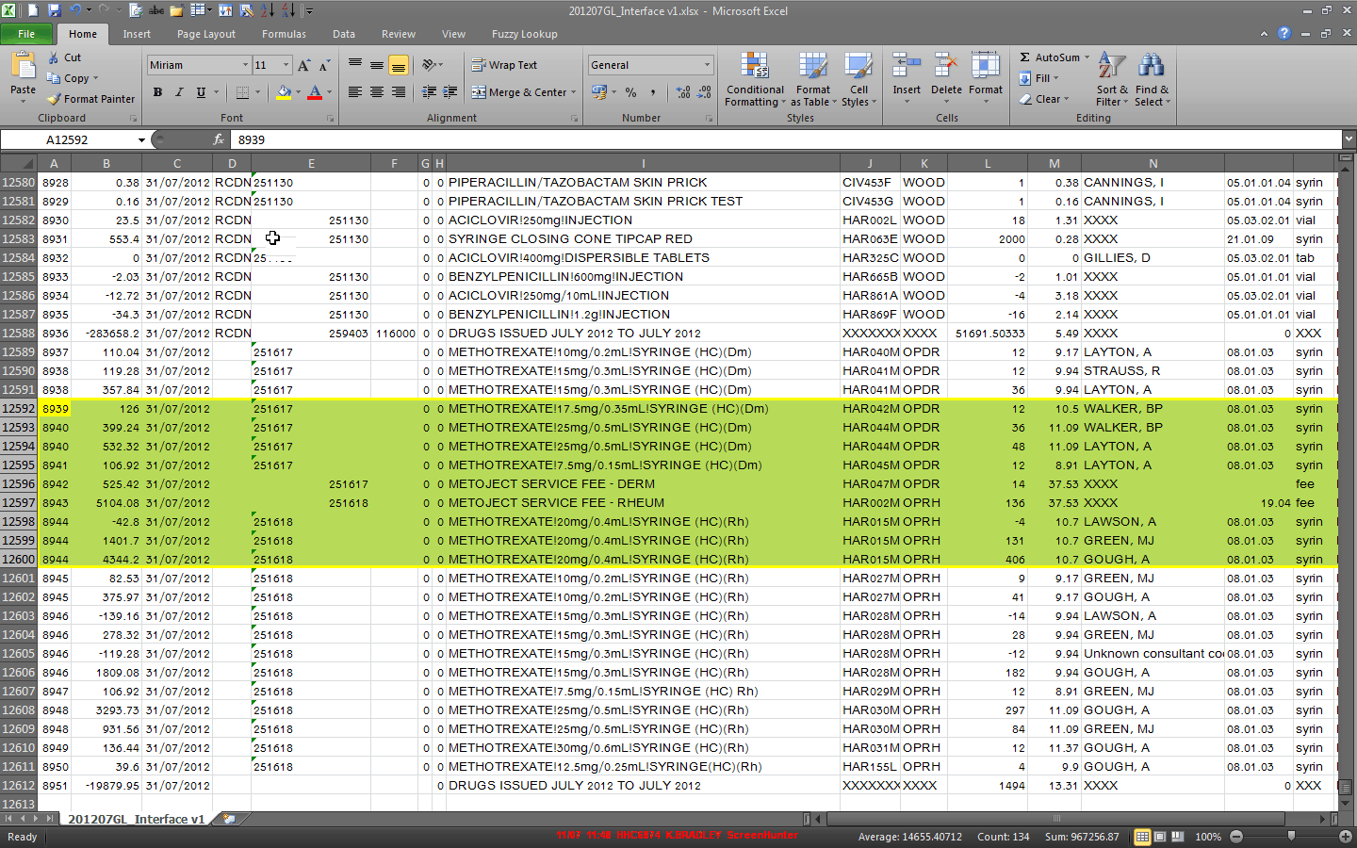

Reporting

Reporting will vary depending on the reporting tools being used by - EIS Reporter, Cognos, Microsoft Reporting Services.
Using the setup described in this document will allow reporting by Site, Supplier, and Drug. Within drug it is possible to report using the NSV code or range of codes, stores description, and or local code. Using the patient’s number as requisition number when issuing service fees allows for the identification of fees with drugs to give a total cost per patient.

Finance Manager
If a separate stock-holding is setup then Finance Manager will provide a balance sheet for all or individual products:
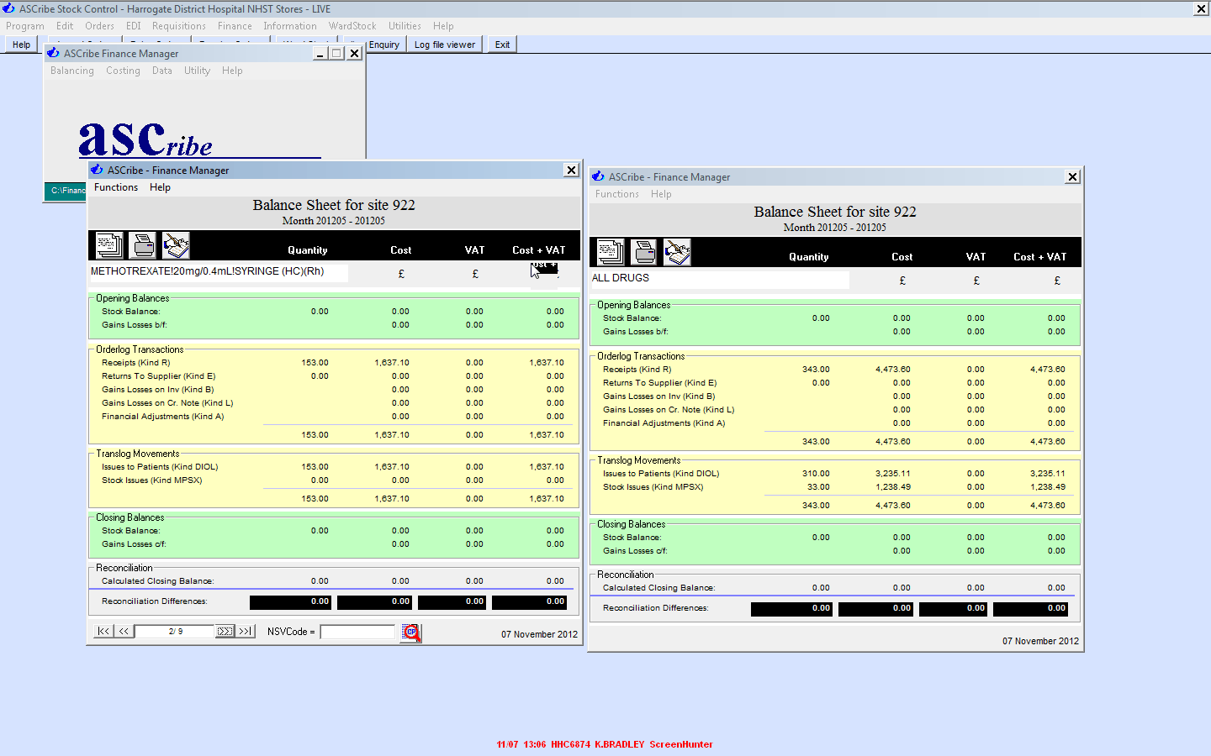

Appendix A – Setup Drugs and Other Costs (Service Fees)

Separate Drugs
Import from the Master Drug File and move to the separate Homecare site (where in use). Each drug should be setup separately:

NSV Codes
Your Trust’s normal NSV numbering sequence can be used or a different sequence could be introduced to aid reporting i.e. a sequence of NSV codes just for homecare drugs e.g. HCD001A

Drug Descriptions
(HC) can be added as suffix to the Stores Drug Description Field to aid reporting and to make it easier to identify these drugs on the Patient’s Medication Record.

V.A.T.
V.A.T. code should be 0.

Look-Up Code
The standard approach with multiple stock-holdings is to add all drugs to the main (Stores) site and then import from Stores to other sites. If using a separate homecare site, the drugs added to the main site can be “hidden” from use by changing the look-up code to ZZZZ9999.

Ledger Codes
Ledger codes added in this field take priority in the GL interface creation ensuring that the usage is correctly coded as per your Finance team’s requirements.

Local Codes
The local codes field can be used as a structured coding field for additional identification of these products for reporting.

Contract Prices
Homecare drugs will be subject to Regional/Local contracting arrangements and the contract fields should reflect this – contact details should be entered via Stores/Utilities/Amend Drug Contract Prices.

Notes
A standard comment can be added to the notes field e.g. ‘Used by Homecare Team’. This helps to prevent the homecare drugs from being ordered in the normal ordering process.

Service Fees and Other Costs

Service fees and other costs should be setup as products. They should be separated from drug costs (where possible) but will need allocating to a ledger code. This can be done by setting-up cost centres for each therapy area e.g. Methotrexate (Rheu) and Methotrexate (Derm) and having ward-stock lists containing just the service fees or other costs.

Cost Centres for Services Fees
Cost centres can be setup as normal “wards”, with the relevant cost centre added for interface purposes. Entering the print picking ticket field as “Y” allows entry of a requisition number at the time of issue ( See 7.2).
Using HP for Homecare
(Examples from North Bristol NHS Trust - Andrew.davies@nbt.nhs.uk)

