RPS RCGP CPCS Training

Phase 2 - End of Project Report

1 April 2022 – 30 April 2023

The Supplier | Royal Pharmaceutical Society (RPS)
The Authority | Health Education England (HEE)
Reporting Period | 1st April 2022 – 27th April 2023
Authors | Beth Ward, Interim Associate Director of Education (RPS)  Anna Domin, Administration Manager (RPS)
Date | 19th May 2023

Table of Contents

Introduction 2
1. Approach to training 3
2. Project teams 6
3. Engagement strategy 7
4. Overall achievements 7
5. Quality data, feedback and testimonials 14
6. Financials 21

Introduction
A key aspect of the NHS Community Pharmacist Consultation Service requires pharmacists to perform clinical consultations and examinations to assess patients’ needs, provide care, safety netting advice, and where appropriate, either close the consultation or refer to other care settings.
These skills vary widely across the workforce, therefore, to support pharmacists to be confident in delivering clinical consultations and assessments, the Royal Pharmaceutical Society in partnership with Royal College of General Practitioners (RPS/RCGP) was commissioned by Health Education England to deliver clinical consultation and assessment skills training areas to community pharmacists across England which can be described in 2 phases of activity.
Phase 1 of contract delivery ran between October 2022 and March 2023, and comprised core clinical assessment and consultation skills training. Full details of phase 1 are described in the end of Phase 1 project report provided to HEE in April 2022.
Phase 2 of contract delivery ran between April 2022 and April 2023. This CPCS Clinical Training Programme comprised:
- small group learning clinical training across several 6 specific clinical areas, and one course consolidating learning from across the programme.
- plenary style discussion and Q&A sessions, led by clinical experts.
Topics for this programme were selected following review of the extensive learner feedback gathered across phase 1 of delivery, and NHS England’s data on actual service referrals.
The phase 2 training programme consisted of face-to-face workshops delivered by multi-professional teams including an expert from each specific clinical area of practice, and a team of GPs, advanced nurse practitioner and pharmacist facilitators, with each session Chaired by a pharmacist. Additional case studies and quizzes were also made available to learners following sessions.
The programme has been designed to be relevant to practice and encourage pharmacists to reflect on their place as a practitioner within the wider health systems.
The RCGP/RPS CPCS Clinical Training Programme has improved the confidence and clinical skills of pharmacists working in community pharmacies in England. With over 5000 attendees across all sessions, 90% of survey respondents reported more confidence in identifying red flags in consultations to enable safe, effective, clinical management and/or referral of patients, positively impacting patient care.

Approach to training
1.1 Small group learning

Session Overview
Table 1 provides an overview of small group CPCS clinical training sessions developed and delivered by RPS/RCGP.

Topic | Themes
Dermatology 1 | - Understand the impact of skin disease and the pharmacist’s role  - Elicit a basic clinical history and perform a skin assessment  - Recognise dry skin conditions and advise on management  - Support patients with atopic eczema  - Recommend management for acne vulgaris  - Provide valid advice to patients with rosacea  - Understand red flags and when to refer
Dermatology 2 | - Identify common viral skin infections, options for treatment and when to refer  - Recognise fungal and yeast infections of the skin including tinea pedis, incognito and pityriasis versicolor  - Detect impetigo and advise on community treatment  - Feel confident to identify and treat scabies infestation  - Advise patients regarding the management of thread worms and tick bites
Eye conditions 1 | - Describe the anatomy of the anterior eye  - Take a history from a patient with a red eye  - Identify red flag signs/symptoms in a red eye  - Manage bacterial, allergic and viral conjunctivitis  - Understand referral pathways in your local area
Eye conditions 2 | - Distinguish dry eye conditions from other conditions with similar symptoms and know when to refer  - Identify risk factors for dry eye symptoms and offer advice to reduce these  - Recommend a range of treatment options for the relief of dry eye symptoms  - Assess adherence to treatment with eye drop formulations and find solutions to any issues  - Identify and offer recommendations to manage blepharitis and other conditions causing red eyes
Paediatrics 1 | - Describe symptoms and most likely causes of common paediatric gastroenterology presentations  - Recognise red flags requiring referral to primary or secondary care  - Interpret main signs, symptoms and parameters relating to paediatric gastroenterology conditions  - Evaluate the needs of individual patients to make judgements on most appropriate course of action
Paediatrics 2 | - Perform a clinical risk assessment of the child or young person presenting with a suspected infection using national guidance  - Recognise red flags and arrange onward referral to an alternative healthcare provider  - Describe the signs and symptoms of infection and sepsis in children and young people  - Appreciate the wider impacts of sepsis on children, young people, and their families
Women’s health | - Describe women's anatomy and the hormonal cycle  - Undertake a women's health consultation  - Manage a patient presenting with menstrual pain  - Manage a patient presenting with normal and abnormal vaginal discharge  - Identify causes of and management options for bladder pain
Respiratory 1 | - Describe the anatomy of the airways  - List the common causes of acute cough  - Assess a patient presenting with a cough by using history taking and clinical signs  - Identify red flags for cough  - Describe self-care advice and over the counter preparations for cough
Respiratory 2 | - Assess patients presenting with conditions affecting the respiratory tract  - Describe good inhaler technique, linking it to shared decision making & environmental sustainability  - Identify ways to review and optimise asthma care  - Describe the fundamentals of COPD care  - Recommend smoking cessation interventions and self-care  - Identify factors influencing medication non-adherence
Consolidated clinical assessment skills and focus on remote consultations | - Demonstrate a structured, person-centred approach to clinical history taking.  - Understand and apply tools to effectively undertake a mental health assessment.  - Discuss the principles of remote consultation skills.  - Demonstrate a range of clinical skills assessments.  - Identify presenting red flags in the consultation to enable safe, effective, transfer and safety netting of patients
Table 1: Overview of RPS RCGP CPCS Clinical Training Sessions

Session Delivery

The delivery team for each clinical session included:

Clinical educators were quality assured by the RPS, ensuring they were specialists within the topic area, and experienced in the development and delivery of educational content.

Clinical Facilitators were GPs, advanced primary care practitioners (nurses, pharmacists, paramedics), quality assured by RCGP, ensuring they had previous education delivery experience, and received training specific to the delivery of this course.

Chairs were experienced pharmacists with knowledge of the NHS CPCS, who also received training specific to the delivery of this course.
Each session followed the consistent format of:

Session length and learner numbers

Until December 2022, each live training session was 2 hours long, with learner numbers capped at 100.

Learners and facilitators requested that additional time was provided to maximise the rich-learning experience offered by the small group facilitated case study discussions, therefore from January 2023, sessions were extended to 2.5 hours duration.

Additionally, due to significant demand for sessions, the cap on learner numbers was removed. Additional facilitators were recruited to ensure the ratio of one facilitator to 8 learners was retained, maintaining the optimised learner experience.

Learners and facilitators were all provided with online, interactive handbooks.

Post session, materials made available to learners included:
- Copies of session slides
- Model answers for all case studies
- 1 x additional (new) case study
- Single best answer quiz (10 questions), designed following RPS Assessment development guidance

Courses were available during the following timeslots:
- Tuesday evenings at 7pm
- Wednesday evenings at 7pm
- Thursday mornings at 9.30am
- Sunday mornings at 9.30am

Content development

RPS Quality Standards for the development and quality assurance of all learning content and feedback were followed by the Quality Team. The overarching learning outcomes for each course were discussed with the were as follows:

  - Describe the pathophysiology of multiple conditions within the clinical area.
  - Explain common terms to describe the various conditions.
  - Identify the common presentations of multiple conditions.
  - Practice the knowledge and skills required to carry out a clinical consultation.
  - Demonstrate the ability to treat or refer a patient.
  - Identify red flags associated with the condition.

1.2 Plenary sessions
Each interactive session was Chaired by a pharmacist facilitator and one or more clinical specialists from the relevant topic area.

Learners were encouraged to submit questions at the point of registration, to be answered live during the session, in addition to participating in the live Q&A and polling questions throughout the session.

Sessions were all recorded and made available on the RPS website (open access).

Table 2 provides a summary of plenary sessions:

Session | Themes
1 | Collaboration with PharmOutcomes: practical use of the platform, live demo, Q&A
2 | Optimising skill-mix: the role of the wider team in delivering CPCS
3 | Dermatology: Common skin conditions in children
4 | Dermatology: recap and Q&A
5 | Collaboration with the Self-Care Forum and NPPG: Management of Strep A
Table 2: Plenary sessions 2022-2023

Project teams
Four teams were responsible for the RPS RCGP CPCS Clinical Training project.
The Project management team was responsible for managing the contract, finances, and project risks.

The Course Development and Quality Assurance team was responsible for the development and quality assurance of all session materials, ensuring they met RPS/RCGP Quality Standards.

The Delivery team ensured consistent and timely delivery of the course, including stakeholder engagement, recruitment of learners, scheduling of facilitators and chairs. The Quality Team was responsible for ensuring the course was consistently delivered to a high standard.

Project Management Team
- Beth Ward (RPS Associate Director of Education)
- Anna Domin (RPS Project Support Officer)
- Calvin Smith (RPS Head of Business Development; DPO)

Course Development & Quality Assurance Team
- Beth Ward (RPS Associate Director of Education)
- Harun Juwale (RPS Education and Training Pharmacist – until September 2022)
- Janice Jenkins (RPS Chair of Community Pharmacy Expert Advisory Group)
- Ann Sunderland (RCGP Clinical Lead)
- RPS Clinical Specialists – Clinical Educators for content development, peer review and delivery (topic specific):
  - Ophthalmology
    - Dr Catherine Porter, Senior Lecturer in Optometry, University of Manchester; General Optical Council
    - Lloyd Thomas, Advanced Specialist Pharmacist in Ophthalmology, Oxford University Hospitals
  - Dermatology
    - Dr Stephanie Gallard, BSc (Hons) Pharmacy, MBCHB, Dip Prac Derm; Primary Care Dermatology Society
    - Dr Tamara Griffith, MD FRCP, Consultant Dermatologist, British Association of Dermatologists
  - Paediatrics
    - Chris Paget, EPMA Pharmacy Lead, Manchester University NHS Foundation Trust / Clinical Lecturer in Paediatric Pharmacy Practice, University of Manchester
    - Richard Goodwin, Principal Pharmacist Education and Training, Great Ormond Street Hospital; Neonatal and Paediatric Pharmacy Group London Co-Chair.
  - Respiratory
    - Ravijyot Saggu, CPhO’s Clinical Fellow 21/22, Medicines Value Team, NHS England, Chair UKCPA Respiratory Committee, Honorary clinical lecturer, University College London
    - Dr Sam Bartlett-Pestell, National Medical Director's Clinical Fellow 19/20, Respiratory Registrar South London
  - Women’s Health
    - Zoe Van-Zuylen, Research Pharmacist, Imperial College Healthcare NHS Trust; Chair of UKCPA Women’s Health Group Education Lead.
    - Debbie Duncan, Lecturer (Education), School of Nursing & Midwifery, Queens University; RCGP Facilitator
  - Clinical Skills Training Consolidation
    - Dr Umar Chaudrey, GP, Clinical Teaching Fellow, RCGP Examiner
    - Debbie Duncan, Lecturer (Education), School of Nursing & Midwifery, Queens University; RCGP Facilitator.

Delivery Team
Stakeholder management
- Beth Ward (RPS Associate Director of Education)
- Hanna Jenvey (RPS Head of Events Operations)

Event operations
- Hanna Jenvey (RPS Head of Events Operations)
- Samantha Kenny (RPS Head of Events Operations maternity cover from Feb 2023)
- Joanna Asquith (RPS Events Administrator)
- Laura Dove (RPS Senior Events Executive)
- Susie McHardy (RPS Events Assistant)
- Marsha Zuniga-Augustine (RCGP Senior Practice Support Coordinator)

Communications and Marketing
- Neal Patel (RPS Head of Marketing and Communications)
- Sophie Kellett (RPS Communications Executive)
- Anna Pielach (RPS Events Executive)

Intelligence, Research and Analytics
- Helena Rosado (RPS Senior Research Manager)
- Lauren Ross (RPS Science and Research Officer)
- Lauren Toleikis (RPS Head of Insights and Analytics)

Quality Team (session delivery)
- Beth Ward (RPS Associate Director of Education and CPCS Course Chair)
- Janice Jenkins (RPS Chair of Community Pharmacy Expert Advisory Group)
- Ann Sunderland (RCGP Clinical Lead and CPCS Facilitator)
- Naren Duffy (RCGP Head of Programmes)

Engagement strategy
Our communication strategy centred around each module’s clinical content, highlighting benefits of undertaking additional training in the various clinical areas.

Our most important channel was direct email marketing, which enabled us to effectively communicate directly with our target audience of community pharmacists in England.

A key focus of email communication was on the small group nature of the training, and the accessibility of our high-quality, expert clinical educators and facilitators.

As modules ran over consecutive blocks, we also sent targeted emails to delegates who had previously attended a module, encouraging them to complete all training modules.

This activity was supported by social media marketing across Twitter, LinkedIn, and Facebook.

We consulted directly with Schools of Pharmacy to establish bookings for MPharm CPCS CPD courses.

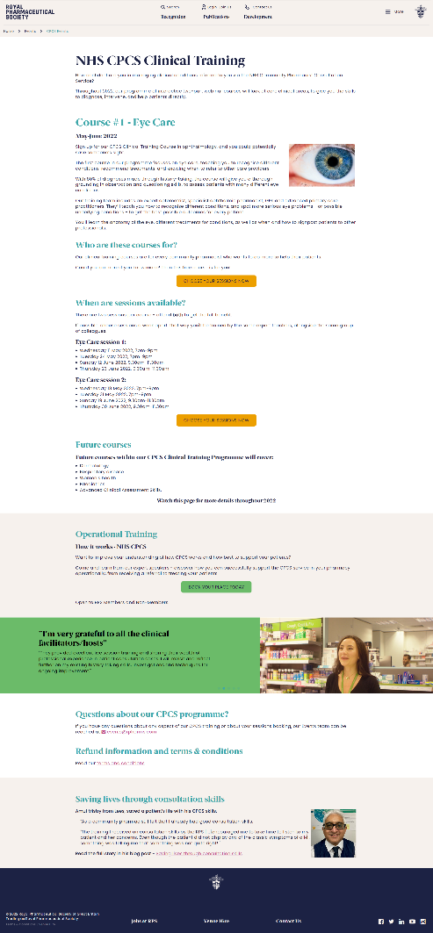
Below are some examples of our email and social media communications:


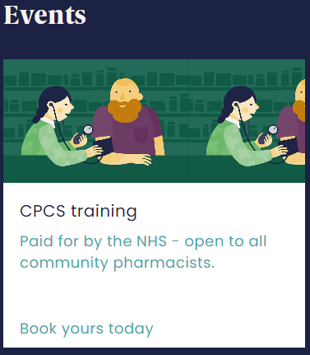

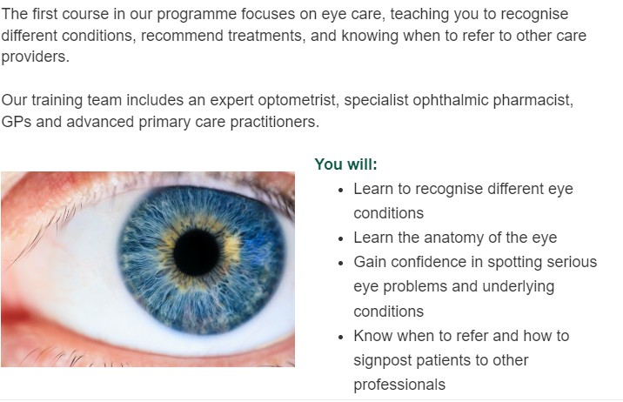
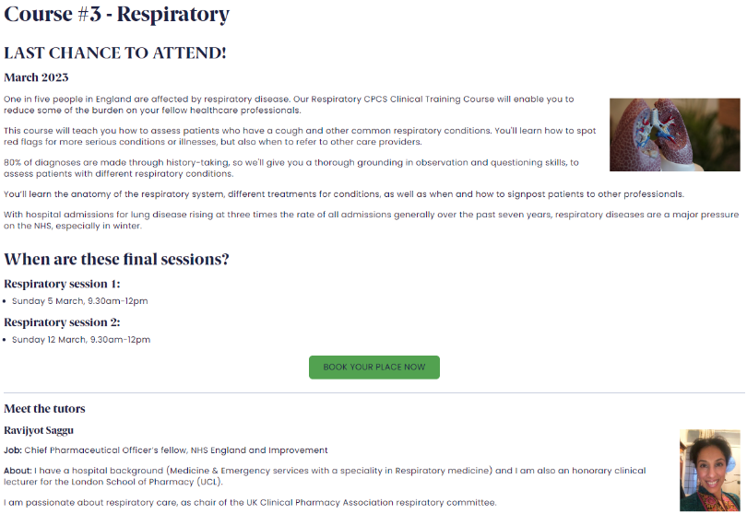
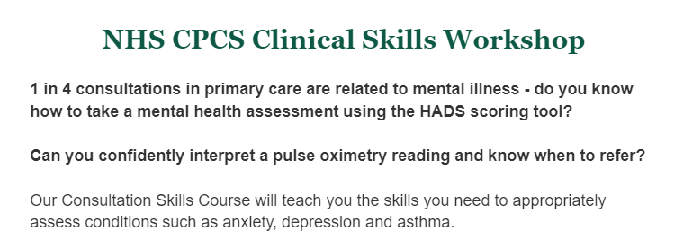

Overall achievements
4.1 Key statistics
Between 1st April 2022 and 27th April 2023:
CPCS Clinical Training Programme:
- Received 6376 bookings with 5102 learner attendances.
- Delivered 73 RPS RCGP CPCS Clinical Skills online events.
- Average quality survey response rate per topic:
  - Ophthalmology – 24.5%
  - Dermatology – 23%
  - Respiratory – 29%
  - Paediatrics – 30%
  - Clinical Skills – 25%
  - Women’s Health – 37%

- Collated feedback showed:
  - 92% of respondents found the Clinical Specialist’s session ‘useful or very useful’. This session described the clinical conditions, signs, symptoms, red flags, and treatment.
  - Following the clinical specialist session, small group discussions and case studies, 91% of respondents felt more confident identifying red flags in the consultation to enable safe, effective, clinical management and/or referral of the individual after the training compared to before.
  - 99% of respondents found the overall course experience to be a ‘good or very good’.
Core CPCS CPD course:
- We received 748 MPharm student bookings.
- 99% of respondents found the overall course experience to be a ‘good or very good’.

4.2 Programme Delivery
RPS/RCGP CPCS Clinical Training Programme
In phase 2, we delivered 73 CPCS Clinical Skills online events. Detailed information is shown in Table 3 below.

CPCS Sessions | Course dates | Max  number of bookings* | Number of Bookings | Number of Attendees
Plenary Session 1: PharmOutcomes | 6 April 2022 | n/a | 191 | 112
Plenary Session 2: CPCS and the team | 28 April 2022 | n/a | 107 | 51
Ophthalmology Session 1 | May/June 2022 | 120 per session | 467 | 347
Ophthalmology Session 2 | May/June 2022 | 120 per session | 464 | 357
TOTAL |  |  | 931 | 704
Dermatology Session 1 | July/ Sept 2022 | 125 per session | 476 | 387
Dermatology Session 2 | July/ Sept 2022 | 125 per session | 468 | 381
TOTAL |  |  | 944 | 768
Respiratory Session 1 | Oct/ Nov 2022 | 135 per session | 442 | 374
Respiratory Session 2 | Oct/Nov/Dec 2022 | 135 per session | 436 | 361
TOTAL |  |  | 878 | 735
Paediatrics Session 1 | Jan/ Feb 2023 | N/A | 534 | 474
Paediatrics Session 2 | Jan/ Feb/ March 2023 | N/A | 502 | 433
TOTAL |  |  | 1036 | 907
Clinical Skills | Jan 2023 | N/A | 128 | 102
 | Feb 2023 | N/A | 267 | 218
TOTAL |  |  | 395 | 320
Women’s Health | March 2023 | N/A | 244 | 215
 | April 2023 | N/A | 216 | 185
TOTAL |  |  | 460 | 400
Single module repeats and plenaries
Eye Care | 1 March | N/A | 127 | 108
Eye Care | 8 March | N/A | 124 | 106
Respiratory | 5 March | N/A | 98 | 76
Respiratory | 12 March | N/A | 93 | 77
Dermatology | 2 March | N/A | 268 | 199
Paediatrics | 18 April | N/A | 138 | 122
Paediatrics | 25 April | N/A | 159 | 111
Plenary 3: Common skin conditions in children | 22 March | N/A | 152 | 129
Plenary 4: Dermatology | 24 April | N/A | 153 | 110
Plenary 5: Management of Strep A | 26 April | N/A | 122 | 67
TOTAL |  |  | 1434 | 1105
OVERALL TOTAL |  |  | 6376 | 5102
Table 3: CPCS Clinical Training Programme Delivery figures April 2022 – April 2023
Of the 5102 attendees at the clinical training sessions, there were 1,604 unique learners.
Table 4 shows the number of learners who attended 1 or more courses within the programme.

Sessions | Number of learners
Attended 1 | 878
Attended 2 | 290
Attended 3 | 175
Attended 4 | 102
Attended 5 | 90
Attended 6 | 69
Table 4: Number of learners attending multiple courses within the CPCS Clinical Training Programme

Core CPCS CPD Course: MPharm students

Following the success of delivering the core CPCS CPD Course to students in 2022, in December 2022, HEE commissioned RPS/RCGP to offer the course to year 3 and 4 MPharm students.

All Schools of Pharmacy were invited to register their interest in accessing CPCS workshops in December 2022. Table 5 provides details of sessions delivered.

Due to the timing of approval to run these sessions, certain Schools of Pharmacy were not able to accommodate the sessions within their programme due to scheduling conflicts.

School of Pharmacy | Course dates | Confirmed Bookings
University of Sunderland | 27 Jan & 3 Feb | 73
University of Sunderland | 1 & 8 Feb | 46
Birmingham University | 5 & 12 Feb | 83
Liverpool University | 17 & 22 Feb | 36
University of Manchester | 28 Feb & 7 March | 124
University of Central Lancashire | 6 & 13 March | 70
Kingston University | 6 & 13 March | 129
University of Wolverhampton | 8 & 15 March | 50
University of Bradford | 14 & 21 March | 73
De Montfort University | 30 March & 6 April | 64
Total |  | 748
Table 5: CPCS CPD Course: 2023 University Bookings

Quality data, feedback, and testimonials

Quality Team
Throughout the course of the programme, a continuous quality improvement approach was adopted with regular RPS/RCGP Quality Team meetings conducted to review qualitative and quantitative course feedback from learners, Chairs and Clinical Facilitators. Feedback, as well as intelligence regarding evolution of the service was used to inform any modifications to messaging or course delivery, in order to optimise the learning experience.

Significant Event Process
The Quality Team additionally established and monitored the process of reporting and managing significant events. No significant events were reported in phase 2.

Communicating with Chairs and Facilitators
Following each Quality Meeting, a ‘You Said, We Did’ communication was circulated to all Chairs and Facilitators to demonstrate our commitment to listening to feedback and providing any update on changes to service or course delivery.

Additionally, learners were asked to provide names feedback for their Chairs and Facilitators, which was communicated following each Quality Meeting.

Cumulative Quality Reports
All Course Feedback Summary
Course Feedback was obtained from learners, Chairs, Educators and Facilitators immediatley post session.
The cumulative results of this feedback are provided below.

Overall response rate: 22%
Results in this report are expressed in percentages (%) unless otherwise stated. Percentages were calculated using the total number of survey respondents and rounded to the nearest whole number (e.g., 99% or 101%). Therefore, in some cases, responses may not add up to 100%.

Engagement with CPCS and Training

Have you delivered consultations as part of the NHS CPCS | %
Yes, both clinical examinations and emergency supply consultations | 60
Yes, emergency supply consultations | 19
Yes, clinical examination consultations | 6
No | 15
TOTAL | 100

Have you attended core NHS CPCS clinical consultations and assessment skills training previously? (Courses delivered between October 2020 and March 2022) | %
Yes, with RPS/RCGP | 52
Yes, with CPPE | 21
No | 26
TOTAL | 100

How confident are you managing general referrals requiring clinical examinations? | %
Very confident | 5
Confident | 38
Slightly confident | 22
Not at all confident | 1
Not response / Not applicable | 34
TOTAL | 100

Confidence in consultation skills relating to management of clinical presentations.

Learners reported that following the training, they felt more confident in delivering safe and effective clinical consultations in all clinical areas covered.
How confident do you feel about using the following skills after attending the RPS/RCGP course, compared to before? | Less confident | About the same | More confident
Initiating a consultation with a patient | 0 | 23 | 77
Taking a patient’s clinical history including using tools and techniques to demonstrate a structured person-centred approach | 0 | 15 | 84
Applying evidence-based practice and relevant guidance to support clinical reasoning and engage the person in shared decision making | 0 | 15 | 85
Identifying red flags in the consultation to enable safe, effective, clinical management and/or referral of the individual | 0 | 8 | 91
Safely and effectively closing the consultation, including safety netting, signposting and referral when necessary | 0 | 19 | 80

Training Elements
Learners highly rated all elements of the training.
Overall, how useful did you find the following: | Slightly or not at all useful | Somewhat useful | Useful or very useful
Presentation to describe the clinical conditions, signs, symptoms, red flags and treatment | 1 | 8 | 92
Using case-based scenarios to reinforce and reemphasise clinical learning | 0 | 11 | 88
Using the breakout rooms to reinforce and practice consultation skills | 2 | 15 | 83

Event evaluation
The operational delivery of sessions was consistently rated highly by learners.
Please rate the following areas | Poor or very poor | Average | Good or very good
Registration process | 0 | 3 | 97
Joining information | 0 | 2 | 98
Resources provided | 1 | 3 | 96
Presentation slides | 1 | 2 | 98
Facilitators | 0 | 1 | 98
Overall audio / visual | 1 | 3 | 96
Overall experience | 0 | 1 | 99

General feedback about the course
- Attendees were very happy with the sessions, found them informative, and shared positive feedback on the slides, presentations, and innovative discussions.
- The interactive elements of the sessions received extremely positive feedback, as attendees felt these enhanced their learning and kept them engaged.
- The session facilitators received consistent positive feedback for being extremely knowledgeable and for encouraging learners during the breakout group discussions and/or activities.
- There was consistent feedback that the content felt rushed, or that there was not enough time to cover all the slides and/or case-studies. Subsequently, learners felt as though the information was difficult to follow and retain, or that they were not able to take comprehensive notes to refer back to. From January 2023, sessions were extended by 30minutes to provide additional time for learners to engage with experts, facilitators, and peers. Learners were also provided with links to session recordings, and model answers to all case studies following sessions.
- Learners enjoyed the incorporation of personal experiences and tips into several of the sessions.
- The course availability online received positive feedback as this improved access for practitioners in isolated communities.
- Learners found the reference materials shared useful and relevant. Several attendees suggested sharing the presentation slides ahead of the session to help with note taking during the sessions.
- Several attendees mentioned accessibility issues throughout the courses (e.g., audio quality of the presentations). Recordings of sessions were made available learners following the sessions.
- Some attendees would prefer to have shorter sessions if the training was held after a working day, or suggested only holding longer sessions on the weekend.
- As joining instructions were sent via a separate email, they sometimes went to spam. Mentioning this in earlier communications would have been helpful.

Requests for further support/resources
- First aid and emergency care sessions covering, for example, how to use adrenaline from vials, childcare and general first aid delivered in pharmacies.
- Signposting to further information and learning resources focused on red flags.
- Specialty specific referral guides or checklists which pharmacists can use during consultations.
- Session on commonly mistaken conditions, conditions that share common symptoms, and whole person management.
- Sessions focused on clinical information rather than with case-studies.
- Sessions following on from this current series which delve even deeper into the session topics.
- Sessions on medicine combination risks and deprescribing.
- Consistent refresher sessions or online top-up quizzes on the covered topics.
- Future sessions following a similar format on other topics, such as:
  - Women’s health (contraception, and HRT management)
  - Gastrointestinal conditions and their management (e.g., IBS, IBD, etc.)
  - Pain management
  - Mental health
  - Wound management
  - Ear conditions
  - Diabetes & hypertension
Application of learning
Learners were asked to share examples of how they have applied their learning in practice. Across all courses, learners stated that they were using learned skills more routinely and more embedded into practice.

Examples of general skills applied include:
- More structured and interactive consultations (including telephone consultations), clinical examinations, and differential diagnosis
- More effective and confident when conducting in-depth history taking, asking questions in a systematic manner
- Confidently managing CPCS referrals and urgent CPCS medication supply referrals
- Taking a patient-centred consultation approach
- Improved ability to identify red flag symptoms, treating or escalating if required
- The use of the mnemonics and acronyms (ICE, LICEF, SOCRATES, S/SX, I2C6)
- Use of the Calgary-Cambridge and Golden Moment frameworks
- Improved physical consultation assessments (e.g., taking blood pressure and respiratory rate)
- Improved ability to identify and diagnose potentially severe conditions (e.g., sepsis and shingles)
- Understanding and identifying red flag symptoms
- Improved management of OTC queries and emergency supply.

Specific clinical examples included:
- I identified optometrist practices in my local area for referral of appropriate eye care cases.
- I confidently diagnosed bacterial conjunctivitis, provided appropriate advice and treatment recommendation.
- I advised a patient on the management of self-limiting bacterial conjunctivitis instead of supplying OTC chloramphenicol.
- I was able to identify appropriately a red flag situation (cellulitis) and refer on appropriately. Patient was very grateful.
- I can identify the difference between bacterial, allergic and viral conjunctivitis and therefore reduce antibiotic dependence.
- Identifying eczema, and the best treatment.
- I used the red flags part of the training – identified a corneal ulcer and urgently referred the patient to the hospital ophthalmology department.
- I now frequently conduct automated blood pressure monitoring confidently.
- When I ask patients questions about pain, l use the learning to understand the type of pain, how severe and any red flags.

Financials
Breakdown cost of the project

 | Budget spent  2022 Agreement | Budget spent  2023 Agreement
Content Development Costs | £132,550 | £22,250
 | - Content lead  - Content administrator  - Subject Matter Experts - Content development  - Content design (including facilitator guides and handbooks)  - Video content development  - Quality Assurance | Strep-A support package, including webinar development and delivery costs, partnership with Self-Care Forum, development and ongoing review of Self-Care Fact sheet, supplementary resources
Programme Delivery Costs | £371,500 | £137,250
 | - Operational manager  - Events and programme administrator  - Marketing coordinator  - Invoicing  - Facilitator recruitment  - Clinical Lead Facilitators (GP)  - Clinical Facilitators (Nurse)  - Additional user licences for events booking and learning management system  - Additional training webinars for facilitators  - Marketing campaign | Modifications to existing CPCS Clinical Training programme, including:  - Extended session duration costs (sessions now 2.5hrs) from January 2023  - Increased learner attendance (additional 545 learners)  - Additional RCGP administration costs  - Marketing campaign to recruit further learners  - Invoicing  - Additional RCGP Clinical Facilitators (GPs, ANPs, ACPs, advanced pharmacists)  - Additional RPS Chairs  - Additional Expert Clinical Educators  - Additional user licences for events booking and learning management system
 |  | £193,750
 |  | CPCS CPD course for University Students (up to 940 places attending 2xsession course. Cost reflects increase costs for facilitators in the context of CPI; CPPE e-learning access fee)
Total | £504,050 | £353,250

Table 10: Total CPCS Training Programme budget summary

CPCS Additional booking numbers | Budgeted | Actual
Number of MPharm student bookings | 940 | 748
Number of bookings for clinical training sessions above the 2022 Agreement | 545 | 734
Total | 1485 | 1482

Conclusion
In summary, RPS RCGP’s delivery of training to support building the confidence of the community pharmacy workforce in England to deliver the NHS CPCS has been highly successful.
Over phase 1 and 2, between 6th October 2020 and 27th April 2023 we have:
- Delivered 764 online events
- Received 16,933 bookings
- Trained 10,026 pharmacists and trainee pharmacists, over 12,676 session attendances
- Booked 1,741 MPharm students onto sessions
- Received an average overall quality rating of 99%, in terms of survey respondents’ rating of the overall course experience as ‘good or very good’.
- Supported the community pharmacy workforce to be more confident in safely and effectively managing consultations.
- Received some incredible feedback from the learners:
“I NEVER usually enjoy training... but this was different, I actually found myself looking forward to part 2. If I could sign up to the skin session right now I would! Thanks for changing my negative views on CPD :)”

“It was very lovely and informative. Thank you to all the facilitators and the speaker!”

“Great way to improve knowledge, skills and help patient feel better in community”
“Excellent session explaining common eye conditions, red flags etc, presented clearly, supported with slides, and extra links where to refer patients to if needed, very informative.”

“I have recently returned to being a practising community pharmacist after period away and it has given me confidence in asking all the right questions”

“Absolutely excellent session. I found the specialist and real-life information very applicable, and this will definitely improve my practise.”
“The NHS CPCS /RPS workshops were exactly the clinical training I was looking for! More training similar to this would be very useful! THANKYOU”

“Great presentations, I enjoyed learning about these skin conditions as some were not the most common but particularly dangerous (i.e., ocular shingles). Awareness of these conditions makes me more confident in my practice, knowing that I am ruling out anything dangerous”

"The facilitators were the best I have come across. Excellent information and a good CPD opportunity"

