RPS RCGP CPCS Training

Phase 1 - End of Project Report

6 October 2020 – 31 March 2022

The Supplier | Royal Pharmaceutical Society (RPS)
The Authority | Health Education England (HEE)
Reporting Period | 06 October 2020 – 31 March 2022
Authors | Beth Ward, Interim Associate Director of Education (RPS)  Neal Patel, Interim Associate Director of Membership and Marketing (RPS)  Anna Domin, Administration Manager (RPS)
Date | 29 April 2022

Table of Contents

Introduction 3
1. Approach to training 3
2. Project team and delivery team 5
3. Engagement strategy 6
4. Overall achievements 8
5. Quality data, feedback and testimonials 14
6. Financials 22
7. Recognition 23

Introduction
A key aspect of the NHS Community Pharmacist Consultation Service requires pharmacists to perform clinical consultations and examinations to assess patients’ needs, provide care, safety netting advice, and where appropriate, either close the consultation or refer to other care settings.
These skills vary widely across the workforce, therefore to support pharmacists to be confident in delivering clinical consultations and assessments, the Royal Pharmaceutical Society in partnership with Royal College of General Practitioners (RPS/RCGP) was commissioned by Health Education England to deliver clinical consultation and assessment skills training to community pharmacists across England.
This training consists of a CPPE e-learning course and face-to-face workshop delivered by multi-professional teams including GPs, advanced nurse practitioners and pharmacists. The programme has been designed to be relevant to practice and encourage pharmacists to reflect on their place as a practitioner within the wider health systems.
Due to COVID-19, the workshop element was re-designed by RPS into a 2-part interactive, online workshop.
The new interactive online workshops were launched on 6th October 2020 and ran until 31st March 2022.
The RCGP/RPS CPCS programme has improved the confidence and clinical skills of almost half of the community pharmacist workforce in England, reaching almost 8,500 pharmacists, trainee pharmacists and students. With over 90% of learners reporting more confidence using clinical skills developed during our workshops, our programme has improved the clinical care of many thousands of patients through pharmacy, including interventions such as the life-saving early diagnosis of an MI.

Approach to training
The format of the RPS/RCGP course is as follows:

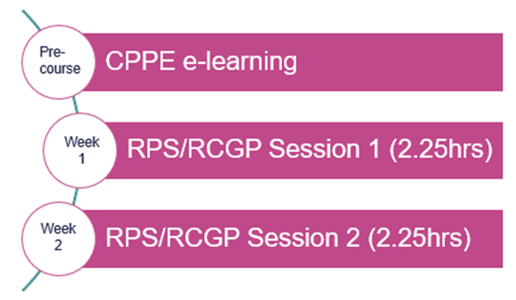

The course was intentionally split across 2 sessions, to allow for skills to be taught in session 1, then reflection and where possible practice to take place between sessions 1 and 2 (with a family member or friend), to support facilitated discussions in session 2.

Each session was Chaired by a pharmacist facilitator, three clinical facilitators (one GP and two advanced primary care practitioners – nurses, pharmacists, paramedics), quality assured by RCGP, ensuring they had previous education delivery experience, and received training specific to the delivery of this course.

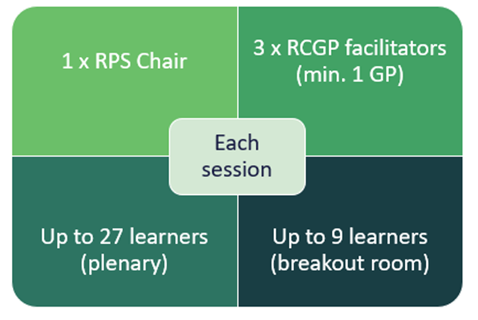
Courses were available during the following time-slots:
- Tuesday evenings at 7pm
- Wednesday evenings at 7pm
- Thursday mornings at 9.30am
- Sunday mornings at 9.30am
- Sunday evenings at 6.30pm.

Up to 5 sessions could be run concurrently, dependant on learner numbers.

The content delivered within each session of the course was as follows:

Session 1
Clinical history taking and consultation skills
- Initiating the consultation, gathering information and preparing for clinical assessment (Calgary Cambridge Model)
- Activity 1: initiating consultation (practice)
- Activity 2: history taking (practice)
Red flags & Observations
- Red Flags
- Activity 3: Red Flags discussion: cardiovascular, infection, respiratory, general
Clinical assessments and observations
- Case-study 1 (Ann - elderly lady with confusion)
- Activity 4: clinical observations
- Activity 5: clinical assessment skills demonstration and discussion (blood pressure, resp rate, pulse rate, O2 saturation)
Summary, homework and close
- Your commitment for session 2 (learners to video themselves practising any of the skills covered, using family/friend as a ‘patient’)

Session 2:
Feedback on learning -clinical assessments and observations
- Feedback on experience
- Activity 6: Peer and facilitator feedback on practice
Case-studies – managing the patient
- Activity 7: Case-study 1 (Morgan – young child with a rash)
- Activity 8: Case-study 2 (Alex – adult male with infection)
Clinical transfer and safety netting, documentation and closing the consultation
- Clinical transfer and safety netting, SBAR
- Activity 9: Documenting and closing
Doing things differently
- Learning from experience (Facilitators sharing their experiences relating to challenging situations)
- Activity 10: Learners discussing their challenging experiences with peer / facilitator to discuss best practice and learning
- Activity 11: Escalating care in and out of hours
- Summary, evaluation, next steps and close

At the point of re-designing the sessions for virtual delivery, activity 10 and 11 were included by RPS/RCGP, to address key factors identified in successful delivery of the service – building or enhancing networks across primary care, and reflecting on challenges and how to utilise networks for support.

Project team and delivery team
Three teams were responsible for the RPS RCGP CPCS project. The Project management team was responsible for managing the tender process, contract, finances and project risks. The Delivery team ensured consistent and timely delivery of the course, including stakeholder engagement, recruitment of learners, scheduling of facilitators and chairs. The Quality Team was responsible for ensuring the course was consistently delivered to a high standard.

Project Management:
- Gail Fleming (RPS Director of Education and Professional Development)
- Chuxx Onyia (Oct 2020 – May 2021) (RPS CPCS Project Manager)
- Anna Domin (RPS Project Support Officer)

Delivery Team:
Course Development & Quality Assurance:
- Beth Ward (RPS Head of Education)

Stakeholder management:
- Gail Fleming
- Ravi Sharma (RPS Director of England)

Course delivery
- Hanna Jenvey (RPS Head of Events Operations)
- Naren Duffy (RCGP Head of Programmes)
- Cassie Forbes (RCGP Programme Operations Manager | Primary Care Development Team)

Communications and Marketing
- Neal Patel (RPS Head of Marketing and Communications)
- Anna Pielach (RPS Events Executive)
- Sophie Kellett (RPS Communications Executive)

Intelligence, Research and Analytics:
- Helena Rosado (RPS Senior Research Manager)
- Eva Lash (RPS Research Officer)
- Lauren Toleikis (RPS Head of Insights and Analytics)

Quality Team:
- Beth Ward (RPS and course Chair)
- Gail Fleming (RPS and course Chair)
- Naren Duffy
- Cassie Forbes
- Helene Irvine (RCGP Clinical Lead)
- Andre Yeung (CPCS Expert Advisor)

Engagement strategy
Our overarching communication strategy centred on communicating the value of the CPCS CPD course to two key audiences:

- Community Pharmacists and Foundation Trainees
- Stakeholders, including pharmacy employers, other pharmacy organisations both regional and national

The impact of communicating with delegates directly as well as having our message re-enforced by their employer, trade body or local pharmaceutical committee meant we increased our reach considerably.

As well as our traditional digital channels we also used out-bound calls as a form of two-way communication. This helped us learn from pharmacists what part of the NHS CPCS CPS course and messaging resonated the most as well as giving us another direct route to contact delegates about booking onto the course.

Our most important channels were online search and direct email. The benefit of including stakeholders in our communications was borne out through ‘referral traffic’ we received to the RPS CPCS CPD web pages from third parties. We also used a mix of targeted social media advertising and online retargeting to make sure reminders about the courses were constantly re-enforced.

We trialled direct physical mail, which we quickly discontinued due to low impact.

Below are some examples of messaging and design we used to communicate the value of the NHS CPCS CPD course:

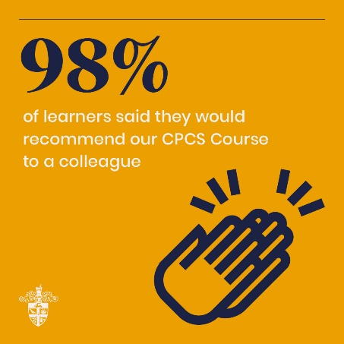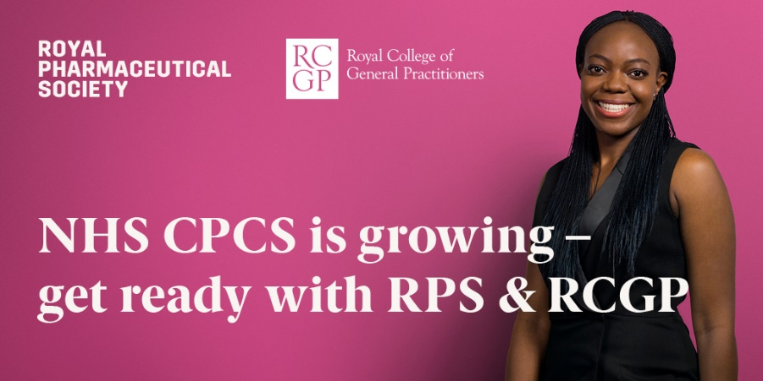
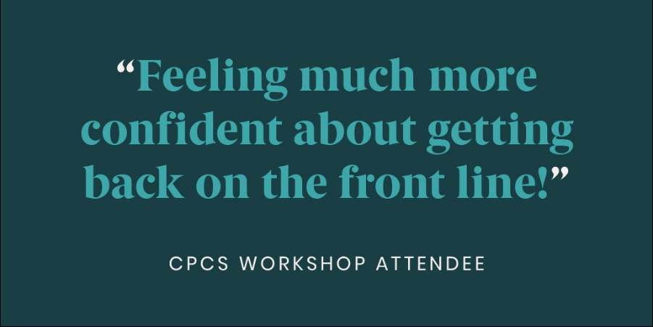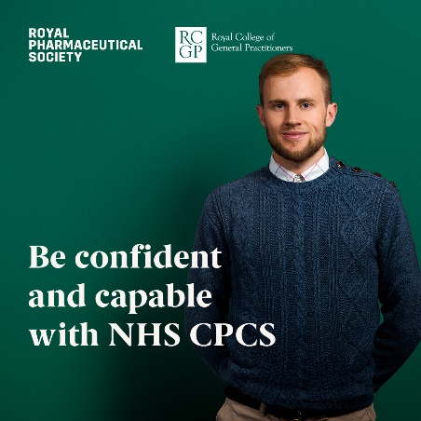
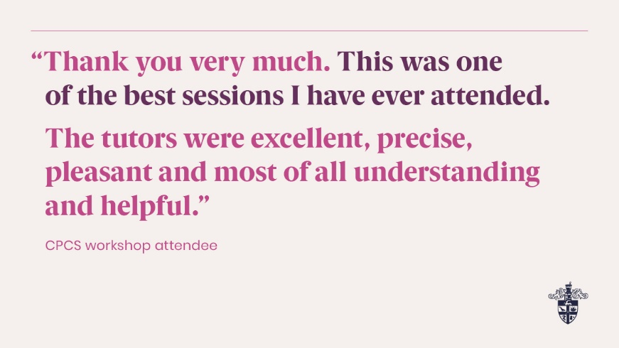

Overall achievements

Key statistics
Between 6th October 2020 and 31st March 2022:
- We reached a total of 11,150 bookings and trained a total of 8422 pharmacists, trainee pharmacists and MPharm students
- The quality survey response rate was 26%
- 98% of respondents would recommend this course to colleagues
- 94% of respondents found the RPS RCGP CPCS training to be ‘useful or very useful’, and 98% of respondents had a ‘good or very good’ overall experience
- Learners reported increased confidence levels across all learning outcomes after CPCS training, compared to before.

CPCS Core CPD for pharmacists and foundation trainee pharmacists
As of 31 March 2022, we have delivered 691 RPS RCGP CPCS online events, that is 346 full courses. We have reached 10557 bookings and trained a total of 7574 pharmacists and trainee pharmacists.
Since October 2020 we have delivered dedicated sessions to individual stakeholder. The following stakeholders and their pharmacists/trainee pharmacists have attended RPS RCGP CPCS courses:
- Tesco – 652
- Avicenna – 165
- Lloyds – 95
- Asda – 68
- Well – 68
- NPA – 41
- Buttercups – 35
- Superdrug – 24
- Kamson – 18

Table 1: CPCS training: Delivery Figures October 2020 – March 2022

Course months | Number of  Courses | No of bookings  (head count) | No of cancellations  (by learners) | No of learners (expected) | No of learners (attended) | Did not attend
Oct 2020 | 28 | 728 | 94 | 636 | 568 | 68
Nov 2020 | 11 | 675 | 86 | 535 | 513 | 22
Dec 2020 | 12 | 339 | 53 | 286 | 263 | 23
Jan 2021 | 26 | 697 | 61 | 637 | 607 | 30
Feb 2021 | 27 | 775 | 98 | 682 | 625 | 57
Mar 2021 | 41 | 1189 | 181 | 1007 | 922 | 85
Apr 2021 | 22 | 646 | 128 | 518 | 420 | 98
May 2021 | 31 | 881 | 154 | 726 | 583 | 143
Jun 2021 | 28 | 899 | 174 | 725 | 569 | 156
Jul 2021 | 16 | 520 | 153 | 363 | 294 | 69
Aug 2021 | 12 | 223 | 33 | 190 | 173 | 17
Sep 2021 | 13 | 434 | 111 | 334 | 283 | 51
Oct 2021 | 11 | 363 | 75 | 288 | 219 | 69
Nov 2021 | 17 | 613 | 132 | 481 | 418 | 63
Dec 2021 | 2 | 70 | 14 | 56 | 45 | 11
Jan 2022 | 16 | 482 | 89 | 393 | 344 | 49
Feb 2022 | 15 | 481 | 113 | 368 | 315 | 53
Mar 2022 | 18 | 542 | 78 | 464 | 413 | 51
TOTAL | 346 | 10557 | 1827 | 8689 | 7574 | 1115

Table 2: CPCS training: Cancelation vs No Show Rates October 2020 – March 2022

Table 3: CPCS training: Uptake and Engagement October 2020 – March 2022

 | Conversion rate*
Oct-20 | 78%
Nov-20 | 83%
Dec-20 | 78%
Jan-21 | 87%
Feb-21 | 81%
Mar-21 | 78%
Apr-21 | 65%
May-21 | 66%
Jun-21 | 63%
Jul-21 | 57%
Aug-21 | 78%
Sept-21 | 64%
Oct-21 | 60%
Nov-21 | 68%
Dec-21 | 64%
Jan-22 | 71%
Feb-22 | 78%
Mar-22 | 76%

LEARNER NUMBERS

*Conversion rate is in relation to conversion from CPCS bookings to attendance numbers.

Table 4: CPCS training: Summary of Bookings and Engagement October 2020 – March 2022

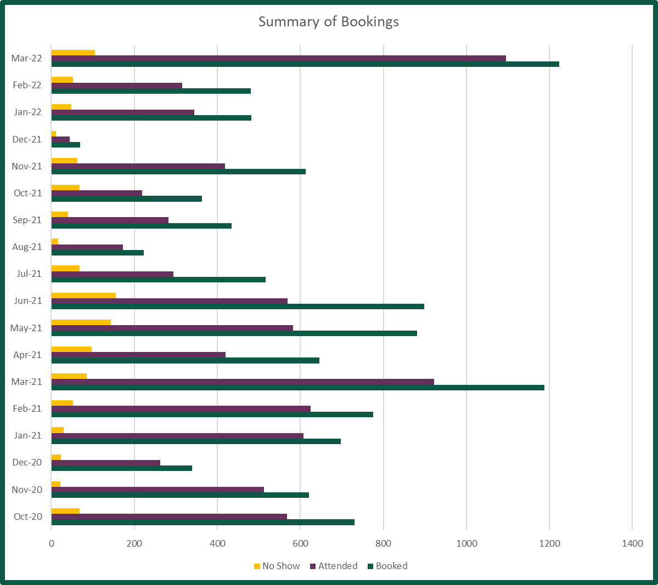

Table 5: CPCS training: Geographical Spread of Learners Trained October 2020 – 06 March 2022

HEE delivery footprint (Regions) | Target | Cumulative total | % of target
LOT 1 (North East and Yorkshire) | 2,265 | 934 | 41%
LOT 2 (North West) | 2,206 | 1163 | 53%
LOT 3 (Midlands) | 2,763 | 1462 | 53%
LOT 4 (East of England) | 1,508 | 760 | 50%
LOT 5 (London) | 2,111 | 1607 | 76%
LOT 6 (South East) | 1,921 | 1075 | 56%
LOT 7 (South West) | 1,226 | 573 | 47%
Total | 14,000 | 7574 | 54%

CPCS Delivery to MPharm students

Following agreement to extend the RPS RCGP CPCS workshops to year 3 and 4 MPharm students we have invited all Schools of Pharmacy to register their interest in accessing CPCS workshops. In March alone we received 682 bookings and run 29 workshops. Overall, we received 993 bookings from 13 Universities as seen in Table 6.

Table 6: CPCS training: Universities Expressions of Interest and Bookings

School of Pharmacy | Anticipated bookings | Course dates | Confirmed bookings | Attendees
Nottingham | 120 | 27 January | 51 | 38
Reading | 100 | 4 & 11 February | 77 | 62
Kingston | 120 | 16 February & 23 March | 150 | 125
Lincoln | 30 | 21 & 28 February | 29 | 26
Bradford | 90 | 24 February & 3 March | 90 | 73
Manchester | 80 | 3 & 10 March | 81 | 78
Wolverhampton | 60 | 9 & 16 March | 61 | 54
De Montfort | 250 | 11 & 17 March | 101 | 90
Newcastle | 100 | 14 & 25 March | 146 | 136
Aston | 70 | 18 March | 77 | 66
Keele | 90 | 18 & 25 March | 49 | 41
Huddersfield | 30 | 29 March | 15 | 15
UCLAN | 60 | 31 March | 66 | 63
Total | 1200 |  | 993 | 790

Quality data, feedback and testimonials

Quality Team
Throughout the course of the programme, a continuous quality improvement approach was adopted with monthly RPS/RCGP Quality Team meetings conducted to review qualitative and quantitative course feedback from learners, Chairs and Clinical Facilitators. Feedback, as well as intelligence regarding evolution of the service was used to inform any modifications to messaging or course delivery, in order to optimise the learning experience.

Significant Event Process
The Quality Team additionally established and monitored the process of reporting and managing significant events. Between October 6th 2020 and March 31st 2022, one significant event was reported by a Clinical Facilitator regarding access and availability to Safe Guarding training for Community Pharmacists.
Working with CPPE, this was addressed through communicating with the profession the importance of safe guarding, the professional responsibilities of pharmacists and pharmacy teams, and availability of updated free-to-access training from CPPE, and updating facilitators on the availability of this training.

Communicating with Chairs and Facilitators
Following each monthly Quality Meeting, a ‘You Said, We Did’ communication was circulated to all Chairs and Facilitators to demonstrate our commitment to listening to feedback, and providing any update on changes to service or course delivery.

Additionally, learners were asked to provide names feedback for their Chairs and Facilitators, which was communicated on a monthly basis.

Quality Improvement – focus groups
Focus group sessions were held in November 2020 and September 2021 with a selection of Clinical Facilitators and Chairs. At each session, feedback summaries were discussed and agree minor modifications to course content and flow were recommended to further optimise the learning experience, and ensure ongoing relevance for learners. Updates to CPCS delivery, for example GP referral pathways, and wider system changes, for example case-finding hypertension service in Community Pharmacies, were also considered.

Cumulative Quality Reports
- Immediate post-course feedback

Course Feedback was obtained from learners, Chairs and Facilitators immediatley post session.
The cumulative results of this feedback are provided below.

Overall response rate: 26.26%

Response rate increased from an average of 18% (Min: 12%, Max: 22%) between Oct 2020 and Jan 2021, to an average of 33% (Min: 19%, Max: 56%) between Jan 2021 and Mar 2022 due to changes implemented to improve response rate (e.g., sharing survey URL in the chatbox).

Results in this report are expressed in percentages (%) unless otherwise stated.
Learners’ confidence providing effective consultations

Have you previously delivered consultations as part of the NHS CPCS (before taking the RPS/RCGP course)? | %
Yes, both clinical examination and emergency supply consultations | 32
Yes, emergency supply consultations | 26
Yes, clinical examination consultations | 5
No | 37
TOTAL | 100

How confident were you managing referrals requiring clinical examinations? | %
Very confident | 10
Confident | 33
Somewhat confident | 39
Slightly confident | 16
Not at all confident | 2
TOTAL | 100

The majority of learners across all cohorts combined rated themselves as more confident about using all skills covered in the course following attendance and the RPS/RCGP course.

How confident do you feel about using the following skills after attending the RPS/RCGP course, compared to before? | Less confident | About the same | More confident
Taking patients’ clinical history, including using tools and techniques to demonstrate a structured person-centred approach | 0 | 4 | 95
Applying evidence-based practice and relevant guidance to support clinical reasoning and engage the person in shared decision making | 0 | 12 | 88
Identifying presenting red flags in the consultation to enable safe, effective, ‘warm’ clinical management and/or referral of the individual | 0 | 9 | 91
Building new or enhancing existing relationships across primary care | 0 | 24 | 76
Using clinical examination skills, including interpreting and applying clinical assessment test results and findings to aid clinical diagnosis and decisions | 0 | 10 | 90
Safely and effectively closing to the consultation, including safety netting, signposting and referral when necessary | 0 | 9 | 91
Completing an accurate and concise clinical record to support data sharing across healthcare settings and transfer of care | 0 | 10 | 90

Content and delivery of the CPCS course

Across all cohorts, the majority of learners rated all elements of the course as useful or very useful.

Overall, how useful did you find the RPS/RCGP course and each one of the sessions? | Slightly or not at all useful | Somewhat useful | Useful or very useful
Clinical history taking, including using tools and techniques to demonstrate a structured person-centred approach | 1 | 6 | 94
Evidence-based practice and relevant guidance to support clinical reasoning and engaging the person in shared decision making | 1 | 12 | 87
Identifying red flags in the consultation to enable safe, effective, clinical management and/or referral of the individual | 1 | 7 | 93
Discussing strategies for building relationships across primary care | 3 | 22 | 75
Demonstration of clinical examination skills, including interpreting and applying clinical assessment test results and findings to aid clinical diagnosis and decisions | 1 | 9 | 90
Opportunity to reflect on and obtain feedback on experience of testing out clinical assessment and consultation skills | 2 | 13 | 85
Safe and effective closure of the consultation, including safety netting, signposting and referral when necessary | 1 | 9 | 91
Completing an accurate and concise clinical record to support data sharing across healthcare settings and transfer of care | 1 | 11 | 88
Case-studies | 1 | 7 | 93
Learning from experience – case stories from facilitators and opportunity to discuss challenging situations | 1 | 9 | 90
Opportunity to discuss course content and practice with the clinical facilitators | 1 | 11 | 88
The RPS/RCGP course overall | 1 | 6 | 94

Overall event experience

The overall event experience across all cohorts was rated as good or very good.

Please rate the following areas | Poor or Very poor | Average | Good or Very Good
Registration process | 0 | 4 | 96
Joining information | 0 | 3 | 96
Resources provided | 1 | 4 | 95
Presentation slides | 1 | 6 | 94
Facilitators | 0 | 1 | 99
Overall audio / visual | 2 | 10 | 88
Overall experience | 0 | 2 | 98

Would you recommend this event to a friend or colleague? | %
Yes | 98
No | 2
TOTAL | 100

A number of learners did not attend a session/(s). A survey was sent out to further understand the reason(s) for this and 156 responses were received, with the majority of respondents (115) stating that they were unable to attend due to personal circumstances (e.g., illness, etc.), 14 stating that they forgot, 7 stating that they didn’t attend session two because they didn’t get much out of session one and 20 respondents giving no reason.

Feedback
The following main themes were identified from the analysis of the information shared in the comment boxes from the survey responses received from learners and facilitators. These themes were consistent across the full duration of course delivery.

Content and delivery
- Feedback about the course, both from learners and facilitators, throughout the course delivery period was consistently positive, and is reflected in the monthly highlight reports.
- Small group learning, and the opportunity to discuss practice with experienced primary care clinicians were highly valued and consistently noted in feedback
- The high quality of clinical facilitators was consistently mentioned. Learners were asked to provide name specific feedback for chairs and facilitators which was shared back with facilitators on a monthly basis.
- The case studies and activities were deemed extremely helpful in bringing the content to life, with constant requests for further case studies.
- The supporting resources were deemed very useful.
- On balance, learners felt the content was pitched at the correct level for learners across all career stages.
  - Those who had completed prescribing courses previously noted that this content was a refresher, and therefore potentially less useful than for those who have not undergone prescribing training.
  - The was variation in feedback from MPharm cohorts – the majority of comments were positive, showing how it aligned with MPharm learning, with many students noting that the timing of this training would have been very useful as preparation for their exams. A small number of students commented that they already felt confident to demonstrate the skills covered in the course.
Further support for learners
Similar requests were made across all Quality Reports, and include:

- Refresher courses in 6-12months
- Further training on identifying common clinical conditions and red flags, including diagnostic tools for community pharmacy.
- Further case-studies to support practice of clinical examination skills.
- Case-studies or other resources to support primary care relationships and developing links with GP consultation Telemedicine services.
- Further support on the regulatory/legal aspects of the NHS CPCS e.g. emergency supply requirements.
- Further information about claiming funding for the services supplied.

Full detail of this feedback has informed the development of the supplementary training commissioned by HEE for delivery over 2022/23.

Clinical facilitators
Overall positive feedback about the clinical facilitators.

General feedback (quotes)
- Discussion with a practising A&E consultant proved very useful to identify action to be taken when identifying a red flag.
- The breakout rooms were useful to share different experiences and perspectives from people. It was helpful to have an experienced clinician to answer any clinical/professional queries that we encounter on a day-to-day basis.
- All sessions were fab especially the videos, the facilitators were energetic and passionate about the topics.
- The facilitator was excellent and very knowledgeable on medical diagnosis.
- Found my breakout group leader very informative.
- All 4 facilitators were brilliant.

Technology
- Overall, no significant problems with the Aventri booking and delivery system
- Some issues with engagement by some learners, particularly those who did not have their camera on. Strategies were implemented to improve engagement including adapted script for Chairs and facilitators, advanced notice of expectation to utilise cameras and audio at the point of registration.

Feedback examples (quotes) from learners
- I found this incredibly useful. Having been on the register for 35 years, things have changed dramatically. I needed to move away from "woolly conversations". I had lost confidence around consultations. I had already covered many CPPE courses on these topics but this cemented that knowledge and has given me confidence. I'm going to watch the skin/ rashes recording next. Thank you.
- I have attended a lot of online courses and this was the first which was engaging, interesting and not difficult to attend after a day at work. Thank you.
- The information was provided in a very structured approach and the sessions were very engaging. There was never a right or wrong answer but an opportunity to improve on previous knowledge. Co-ordinators were very gentle and polite. I had a great time learning new skills.
- Content delivered clearly and at the right level by experts. Practical parts were very helpful as were sections where personal experience was shared.
- Content was directed at right level, good to have mix of backgrounds for facilitators and other delegates.
- Thought the sessions were really well delivered. I particularly liked the case studies and how it involved everyone and challenged our thinking in a really good way.
- Very enjoyable and I feel that I have learnt a lot of new skills to put in to practice and help me feel more confident in my consultations.
- Really liked the mixture of the sessions - theory practice and having the GPs there gave it credibility.
- I think the whole content was useful! The workbook was great as a guide throughout the sessions

- Course Feedback – 3 Month follow-up

Additionally, learners were contacted 3-months post session attendance to provide insights into how their learning has been applied to practice.

Data collected up until March 2022
Overall response rate: 1.8%

Since taking the RPS/RCGP course, have you delivered consultations as part of the NHS CPCS? | %
Yes, both clinical examination and emergency supply consultations | 43
Yes, emergency supply consultations | 30
Yes, clinical examination consultations | 8
No | 19
TOTAL | 100

How confident were you managing referrals requiring clinical examinations? | %
Very confident | 21
Confident | 53
Somewhat confident | 25
Slightly confident | 2
Not at all confident | 0
TOTAL | 100

How confident do you feel about using the following skills 3 months after attending the RPS/RCGP course, compared to before? | Less confident | About the same | More confident
Taking patients’ clinical history, including using tools and techniques to demonstrate a structured person-centred approach | 0 | 29 | 85
Applying evidence-based practice and relevant guidance to support clinical reasoning and engage the person in shared decision making | 0 | 38 | 75
Identifying presenting red flags in the consultation to enable safe, effective, ‘warm’ clinical management and/or referral of the individual | 0 | 24 | 90
Building new or enhancing existing relationships across primary care | 2 | 62 | 50
Using clinical examination skills, including interpreting and applying clinical assessment test results and findings to aid clinical diagnosis and decisions | 4 | 40 | 70
Safely and effectively closing to the consultation, including safety netting, signposting and referral when necessary | 0 | 23 | 91
Completing an accurate and concise clinical record to support data sharing across healthcare settings and transfer of care | 2 | 42 | 70

How much would you value the following support from the RPS, if provided? | Low value | Medium value | High value | TOTAL
Further case-studies/examples of NHS CPCS referrals e.g., how to respond to symptoms, how to refer, etc. | 6 | 18 | 76 | 100
Refresher courses to review, consolidate and/or extend knowledge as the service progresses e.g., 6 months follow-up webinar. | 6 | 41 | 53 | 100
A support network for learners and facilitators to engage post-training and discuss about their practice. | 7 | 40 | 53 | 100

Financials
Core CPCS for Pharmacists and Foundation Trainee Pharmacists Budget summary.

Table 8: Cumulative CPCS delivery cost (October 2020 – March 2022)

Month | Number of learners | Budget spent (£188 per learner, incl VAT)
October 2020 | 568 | £106,784
November 2020 | 513 | £96,444
December 2020 | 263 | £49,444
January 2021 | 607 | £114,116
February 2021 | 625 | £117,500
March 2021 | 922 | £173,336
April 2021 | 420 | £78,960
May 2021 | 583 | £109,604
June 2021 | 569 | £106,972
July 2021 | 294 | £55,272
August 2021 | 173 | £32,524
September 2021 | 283 | £53,204
October 2021 | 219 | £41,172
November 2021 | 418 | £78,584
December 2021 | 45 | £8,460
January 2022 | 344 | £64,672
February 2022 | 315 | £59,220
March 2022 | 413 | £77,644
Running Total | 7,574 | £ 1,423,912

Table 9: MPharm CPCS Delivery Budget summary

Month | Number of learners | Budget spent (£188 per learner, incl VAT)
Jan 2022 | 51 | £9,588
Feb 2022 | 260 | £48,880
Mar 2022 | 682 | £128,216
Running total | 993 | £186,684

Table 10: Total CPCS Budget Summary

CPCS Contract area | Committed budget (excl VAT) | Budget  (incl VAT)
CPCS CPD delivery to pharmacists and foundation trainees | £1,186,593 | £1,423,912
CPCS CPD delivery to MPharm students | £155,570 | £186,684
CPCS Supplementary series | £504,050 | £604,860
Total | £1,846,213 | £2,215,456

Recognition
In 2021, RPS/RCGP and CPPE submitted applications for two awards, to further promote the NHS CPCS, and recognise the work of chairs, clinical facilitators and learners attending the course.

The team were shortlisted for the Training and Development category by Chemist and Druggist.

In September 2021, the team were announced as winners of the Excellence in Clinical Community Pharmacy Practice Award by the Clinical Pharmacy Congress, for demonstrating excellence in training delivery and positive impact on the profession.

